**S.I.G.A.T.**

**Programación III**SURU

|  |  |  |  |  |  |
| --- | --- | --- | --- | --- | --- |
| **ROL** | **APELLIDO** | **NOMBRE** | **C.I.** | **E-MAIL** | **TEL/CEL** |
| Coordinador | Ribeiro | Alex | 5.499.977-6 | alexleonelribeiro@gmail.com | 095220022 |
| Sub-Coordinador | Troche | Gastón | 5.099.726-3 | gtroche12@gmail.com | 094050655 |
| Integrante 1 | Barreira | Santiago | 5.148.730-2 | Santii.bf@gmail.com | 093495491 |
| Integrante 2 | Fernández | Pedro | 5.154.832-8 | Pedro.nacho997@gmail.com | 091358982 |
| Integrante 3 | Cinelli | Germán | 4.664.131-3 | ger.cs28@gmail.com | 096506169 |

**Docente:** Renzo, Bazzano.

|  |
| --- |
| Fecha de Culminación:  31/10/2016 |

**TERCERA ENTREGA**

Indice 1, 2

1.1. Clases y prefijos/Usuarios y claves 3

1.2. Módulo (ConexionODBC) 4

1.3. Pantalla de carga (frmSplash.vb) .5

1.4. Ventana de inicio de sesión (frmLogin.vb) .6

1.5. Ventana de inicio de sesión (frmLogin.vb) .7

1.6. Ventana de inicio de sesión (frmLogin.vb) .8

1.7. Ventana de inicio de sesión (frmLogin.vb) .9

1.8. Menu principal (frmMenu.vb) .10

1.9. Menu principal (frmMenu.vb) .11

1.10. Menu principal (frmMenu.vb) .12

1.11. Menu principal (frmMenu.vb) .13

1.12. Menu principal (frmMenu.vb) .14

1.13. Tambos (frmTambo.vb) .15

1.14. Tambos (frmTambo.vb) .16

1.15. Tambos (frmTambo.vb) .17

1.16. Tambos (frmTambo.vb) .18

1.17. Tambos (frmTambo.vb) .20

1.18. Usuarios (frmUsuario.vb) .21

1.19. Usuarios (frmUsuario.vb) .22

1.20. Usuarios (frmUsuario.vb) .23

1.21. Usuarios (frmUsuario.vb) .24

1.22. Usuarios (frmUsuario.vb) .25

1.23. Vacas (frmVaca.vb) .25

1.24. Vacas (frmVaca.vb) .26

1.25. Vacas (frmVaca.vb) .27

1.26. Vacas (frmVaca.vb) .28

1.27. Toros (frmToro.vb) .29

1.28. Toros (frmToro.vb) .30

1.29. Toros (frmToro.vb) .31

1.30. Toros (frmToro.vb) .32

1.31. Toros (frmToro.vb) .33

1.32. Crías (frmCria.vb) .34

1.33. Crías (frmCria.vb) .35

1.34. Crías (frmCria.vb) .36

1.35. Crías (frmCria.vb) .37

1.36. Crías (frmCria.vb) .38

1.37. Crías (frmCria.vb) .39

1.38. Navegación (frmNavegar.vb) .40

1.39. Navegación (frmNavegar.vb) .41

1.40. Enfermedades (frmEnfermedad.vb) .42

1.41. Enfermedades (frmEnfermedad.vb) .43

1.42. Enfermedades (frmEnfermedad.vb) .44

1.43. Tratamientos/Enfermedades/Controles (frmContrae.vb) .45

1.44. Tratamientos/Enfermedades/Controles (frmContrae.vb) .46

1.45. Tratamientos/Enfermedades/Controles (frmContrae.vb) .47

1.46. Tratamientos/Enfermedades/Controles (frmContrae.vb) .48

1.47 Tratamientos/Enfermedades/Controles (frmContrae.vb) .49

1.48. Producción/Prdeñes (frmOrdenie.vb) .50

1.49. Producción/Prdeñes (frmOrdenie.vb) .51

1.50. Producción/Prdeñes (frmOrdenie.vb) .52

1.51. Producción/Prdeñes (frmOrdenie.vb) .53

1.52. Servicios/Entore (frmServicio.vb) .54

1.53. Servicios/Entore (frmServicio.vb) .55

1.54. Servicios/Entore (frmServicio.vb) .56

1.55. Campos de recría (frmRecria.vb) .57

1.56. Campos de recría (frmRecria.vb) .58

1.57. Campos de recría (frmRecria.vb) .59

1.58. Campos de recría (frmRecria.vb) .60

1.59. Asignar campo de recría (frmRecria2.vb) .61

1.60. Asignar campo de recría (frmRecria2.vb) .62

1.61. Víctimas/Muertes (frmVictima.vb) .63

1.62. Víctimas/Muertes (frmVictima.vb) .64

1.63. Víctimas/Muertes (frmVictima.vb) .65

1.64. Estados de una vaca (frmEstado.vb) .66

1.65. Estados de una vaca (frmEstado.vb) .67

1.66. Estados de una vaca (frmEstado.vb) .68

1.67. Estados de una vaca (frmEstado.vb) .69

2.1. Tutorial: Creación del instalador .70

2.2. Tutorial: Creación del instalador .71

2.3. Tutorial: Creación del instalador .72

2.4. Tutorial: Instalación del programa .73

2.5. Tutorial: Instalación del programa .74

2.6. Tutorial: Instalación del programa .75

2.7. Tutorial: Instalación del programa .76

**Clases y prefijos utilizados en el proyecto:**

|  |  |
| --- | --- |
| Clase | Prefijo |
| Windows Form | frm |
| Label | lbl |
| TextBox | txt |
| Button | btn |
| ComboBox | cbo |
| ListBox | lst |
| GroupBox | gpo |
| RadioButton | rdo |
| ProgressBar | ProgressBar1 |
| Timer | Timer1 |
| CheckBox | chk |

**Usuarios y claves del sistema:**

|  |  |
| --- | --- |
| Usuario | Clave |
| suru_programador | 1234 |
| suru_general | 1234 |
| suru_individual | 1234 |
| suru_auxiliar | 1234 |

ConexionODBC.vb

Module conexionODBC

Public cn As New ADODB.Connection

Public rs As New ADODB.RecordSet

Public sql As String

Public cmd As OleDb.OleDbCommand

Public dr As OleDb.OleDbDataReader

Public Sub validonumero(e)

If Char.IsDigit(e.KeyChar) Then

e.Handled = False

ElseIf Char.IsControl(e.KeyChar) Then

e.Handled = False

Else

e.Handled = True

End If

End Sub

Public Function cargoGrilla(ByVal rs As ADODB.Recordset, ByRef dgv As DataGridView) As Boolean

Dim ok As Boolean

Dim columna, fila As Integer

ok = True

dgv.Rows.Clear()

dgv.Columns.Clear()

If rs.State <> 1 Then

ok = False

Else

If rs.RecordCount < 1 Then

ok = False

Else

For columna = 0 To rs.Fields.Count - 1

dgv.Columns.Add(rs(columna).Name, rs(columna).Name)

Next

rs.MoveFirst()

fila = 0

While Not rs.EOF

dgv.Rows.Add()

For columna = 0 To rs.Fields.Count - 1

dgv(columna, fila).Value = rs(columna).Value

Next

fila = fila + 1

rs.MoveNext()

End While

End If

End If

Return (ok)

End Function

Public Sub cerrar()

cn.Close()

End Sub

End Module

Ventana de carga - frmSplash.vb



Código fuente:

Public Class frmSplash

Private Sub Timer1_Tick(ByVal sender As System.Object, ByVal e As System.EventArgs) Handles Timer1.Tick

ProgressBar2.Visible = False

ProgressBar2.Increment(1)

MarqueeProgressBarControl1.Enabled = True

If (ProgressBar2.Value = 99) Then

Timer1.Stop()

Me.Hide()

System.Threading.Thread.Sleep(2000)

MarqueeProgressBarControl1.Enabled = False

frmLogin.Show()

End If

End Sub

Private Sub Form1_Load(ByVal sender As System.Object, ByVal e As System.EventArgs) Handles MyBase.Load

Timer1.Start()

Timer1.Interval = 45

End Sub

End Class

Ventana de logueo - frmLogin.vb

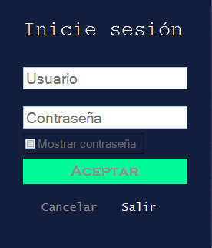

Código fuente:

Public Class frmLogin

Public Sub conectar()

Try

cn.Open("sur1", txtUsuario.Text, txtClave.Text)

'permisos()

MsgBox("Bienvenido! " & txtUsuario.Text & "", MsgBoxStyle.Information, "Acceder")

Me.Close()

System.Threading.Thread.Sleep(2000)

frmMenu.Visible = True

Catch ex As Exception

MsgBox("Usuario o Contraseña incorrecta.", MsgBoxStyle.Exclamation, "Acceder")

limpiar()

Exit Sub

End Try

cn.CursorLocation = ADODB.CursorLocationEnum.adUseClient

End Sub

Public Sub permisos()

Dim rol As Integer

If cn.State <> 1 Then

MsgBox("La conexión a la base de datos está cerrada.")

Else

sql = "select id_rol from usu_rol where id_usuario=(select id_usuario from usuario where login='" & txtUsuario.Text & "')"

Try

MsgBox(sql)

rs.Open(sql, cn)

Catch ex As Exception

MsgBox("Error al buscar el rol del usuario")

Exit Sub

End Try

If rs.RecordCount = 1 Then

rol = rs(0).Value

Select Case rol

Case 1

Case 2

'frmMenu.Visible = True

frmMenu.btnTambo.Enabled = True

frmUsuario.gpoDatos.Enabled = False

frmUsuario.gpoBusqueda.Enabled = False

frmToro.gpoDatos.Enabled = False

frmToro.gpoBusqueda.Enabled = False

frmVaca.gpoDatos.Enabled = False

frmVaca.gpoBusqueda.Enabled = False

frmCria.gpoDatos.Enabled = False

frmCria.gpoBusqueda.Enabled = False

frmContrae.gpoEnf.Enabled = False

frmContrae.gpoTratamiento.Enabled = False

frmContrae.gpoDeclararenf.Enabled = False

frmMenu.btnEnf1.Enabled = False

frmMenu.btnEnf2.Enabled = False

frmEstado.gpoBusqueda.Enabled = False

frmEstado.gpoAniadir.Enabled = False

frmMenu.btnOrdenie1.Enabled = False

frmRecria.gpoRecria.Enabled = False

frmRecria.gpoCamporecria.Enabled = False

frmCria.btnRecria1.Enabled = False

frmServicio.gpoBusqueda.Enabled = False

frmServicio.gpoDatos.Enabled = False

frmVictima.gpoVictima.Enabled = False

Case 3

'frmMenu.Visible = True

frmTambo.gpoBusqueda.Enabled = False

frmTambo.gpoBusqueda.Enabled = False

Case(4)

'frmMenu.Visible = True

frmTambo.gpoBusqueda.Enabled = False

frmTambo.gpoBusqueda.Enabled = False

frmUsuario.gpoBusqueda.Enabled = False

frmUsuario.gpoDatos.Enabled = False

frmToro.btnEliminar.Visible = True

frmVaca.btnEliminar.Visible = True

frmCria.btnEliminar.Visible = True

End Select

Else

MsgBox("No se encontró el rol de usuario")

cn.Close()

End If

rs.Close()

End If

End Sub

Public Sub limpiar()

txtUsuario.Text = ""

txtClave.Text = ""

chkMostrarclave.Checked = False

txtUsuario.Focus()

End Sub

Private Sub frmLogin_Load(ByVal sender As System.Object, ByVal e As System.EventArgs) Handles MyBase.Load

txtUsuario.Focus()

If txtUsuario.Text = "" Or txtClave.Text = "" Then

btnCancelar.Enabled = False

btnAceptar.Enabled = False

Else

btnCancelar.Enabled = True

btnAceptar.Enabled = True

End If

End Sub

Private Sub CheckBox1_CheckedChanged(ByVal sender As System.Object, ByVal e As System.EventArgs)

If chkMostrarclave.Checked Then

txtClave.PasswordChar = ""

Else

txtClave.PasswordChar = "*"

End If

End Sub

Private Sub btnBuscar_Click(sender As System.Object, e As System.EventArgs) Handles btnCancelar.Click

limpiar()

End Sub

Private Sub ButtonX1_Click(sender As System.Object, e As System.EventArgs) Handles btnAceptar.Click

conectar()

'permisos()

End Sub

Private Sub chkMostrarclave_CheckedChanged(sender As System.Object, e As System.EventArgs) Handles chkMostrarclave.CheckedChanged

If chkMostrarclave.Checked = True Then

txtClave.PasswordChar = ""

Else

txtClave.PasswordChar = "*"

End If

End Sub

Private Sub btnSalir_Click(sender As System.Object, e As System.EventArgs) Handles btnSalir.Click

If MsgBox("Está seguro que desea salir del programa", MsgBoxStyle.YesNo, "Salir") = MsgBoxResult.Yes Then

frmMenu.Close()

Else

limpiar()

End If

End Sub

Private Sub txtUsuario_TextChanged(sender As System.Object, e As System.EventArgs) Handles txtUsuario.TextChanged

If txtUsuario.Text = "" Then

btnCancelar.Enabled = False

btnAceptar.Enabled = False

Else

btnCancelar.Enabled = True

btnAceptar.Enabled = True

End If

End Sub

End Class

Menú principal - frmMenu.vb

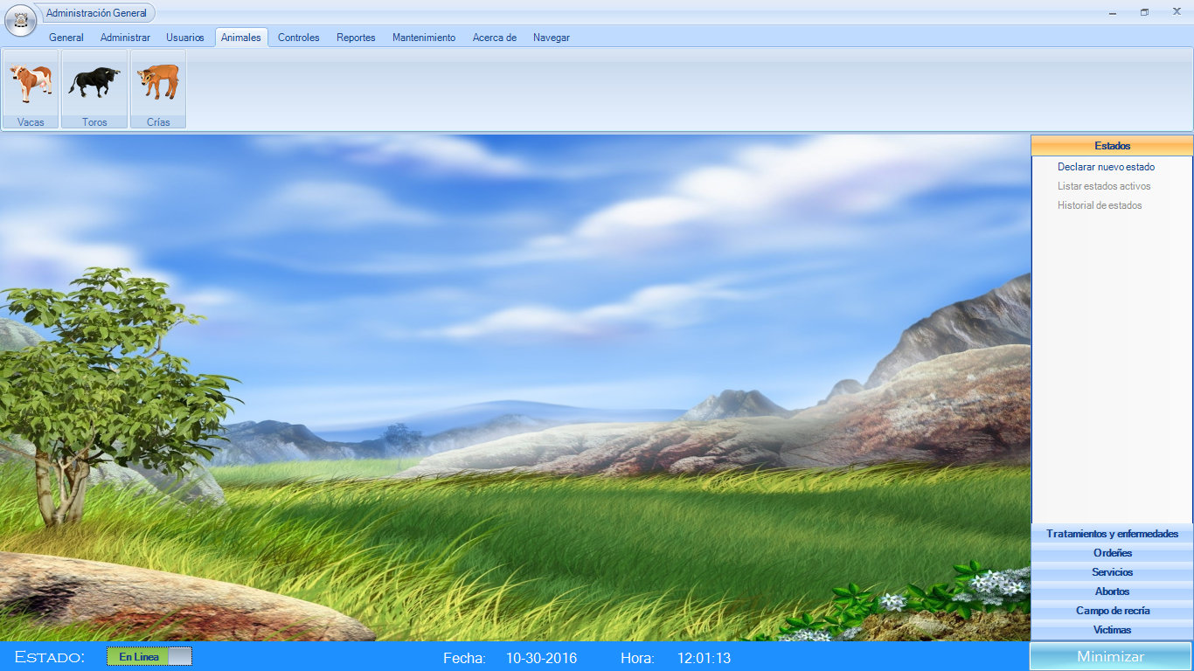

Código fuente:

Public Class frmMenu

Public Sub cerrar_sesion()

NotifyIcon1.ShowBalloonTip(3500, "Atención", "Cerrando sesión...", ToolTipIcon.Info)

System.Threading.Thread.Sleep(3500)

cn.Close()

Me.Visible = False

System.Threading.Thread.Sleep(2000)

frmLogin.Show()

End Sub

Private Sub frmMenu_Load(ByVal sender As System.Object, ByVal e As System.EventArgs) Handles MyBase.Load

Me.Hide()

frmSplash.Show()

End Sub

Sub GestionarClientPanel()

If XtraTabbedMdiManager1.Pages.Count = 0 Then

'ClientPanel.Visible = True()

Panel2.Visible = True

Else

Panel2.Visible = False

End If

End Sub

Private Sub Timer1_Tick(ByVal sender As System.Object, ByVal e As System.EventArgs) Handles Timer1.Tick

lblFecha2.Text = DateString

lblHora2.Text = TimeOfDay

End Sub

Private Sub ButtonItem9_Click(ByVal sender As System.Object, ByVal e As System.EventArgs) Handles btnOrdenie1.Click

frmOrdenie.MdiParent = Me

frmOrdenie.Show()

End Sub

Private Sub ButtonItem19_Click(sender As System.Object, e As System.EventArgs) Handles ButtonItem19.Click

End

End Sub

Private Sub ButtonItem25_Click(sender As System.Object, e As System.EventArgs) Handles btnMenuSalir.Click

If MsgBox("Está seguro que desea salir del programa", MsgBoxStyle.YesNo, "Salir") = MsgBoxResult.Yes Then

Me.Close()

End If

End Sub

Private Sub btnUsuarios_Click(sender As System.Object, e As System.EventArgs)

frmLogin.Show()

Me.Hide()

End Sub

Private Sub NotifyIcon1_MouseDoubleClick(sender As System.Object, e As System.Windows.Forms.MouseEventArgs) Handles NotifyIcon1.MouseDoubleClick

'Mostrar frmMenu

NotifyIcon1.ShowBalloonTip(5000, "Información", "El formulario se ha mostrado", ToolTipIcon.Info)

Me.Show()

End Sub

Private Sub AbrirToolStripMenuItem_Click(sender As System.Object, e As System.EventArgs) Handles AbrirToolStripMenuItem.Click

NotifyIcon1.ShowBalloonTip(5000, "Información", "El formulario se ha mostrado", ToolTipIcon.Info)

Me.Show()

End Sub

Private Sub CerrarToolStripMenuItem_Click(sender As System.Object, e As System.EventArgs) Handles CerrarToolStripMenuItem.Click

If MsgBox("Está seguro que desea salir del programa", MsgBoxStyle.YesNo) = MsgBoxResult.Yes Then

Me.Close()

End If

End Sub

Private Sub ButtonItem10_Click_1(sender As System.Object, e As System.EventArgs) Handles btnUsuario.Click

frmUsuario.MdiParent = Me

frmUsuario.Show()

End Sub

Private Sub btnCrias_Click(sender As System.Object, e As System.EventArgs) Handles btnCrias.Click

frmCria.MdiParent = Me

frmCria.Show()

End Sub

Private Sub ButtonItem5_Click(sender As System.Object, e As System.EventArgs) Handles btnEnf2.Click

frmContrae.MdiParent = Me

frmContrae.Show()

End Sub

Private Sub ButtonItem12_Click(sender As System.Object, e As System.EventArgs) Handles btnEnf4.Click

frmServicio.MdiParent = Me

frmServicio.Show()

End Sub

Private Sub btnVacas_Click(sender As System.Object, e As System.EventArgs) Handles btnVacas.Click

frmVaca.MdiParent = Me

frmVaca.Show()

End Sub

Private Sub btnToros_Click(sender As System.Object, e As System.EventArgs) Handles btnToros.Click

frmToro.MdiParent = Me

frmToro.Show()

End Sub

Private Sub Button3_Click_1(sender As System.Object, e As System.EventArgs)

frmNavegar.Show()

End Sub

Private Sub XtraTabbedMdiManager1_PageAdded(sender As Object, e As DevExpress.XtraTabbedMdi.MdiTabPageEventArgs) Handles XtraTabbedMdiManager1.PageAdded

GestionarClientPanel()

End Sub

Private Sub XtraTabbedMdiManager1_PageRemoved(sender As Object, e As DevExpress.XtraTabbedMdi.MdiTabPageEventArgs) Handles XtraTabbedMdiManager1.PageRemoved

GestionarClientPanel()

End Sub

Private Sub Panel2_Paint(sender As System.Object, e As System.Windows.Forms.PaintEventArgs) Handles Panel2.Paint

Timer1.Start()

Timer1.Interval = 20

End Sub

Private Sub btnDeclararestado_Click(sender As System.Object, e As System.EventArgs) Handles btnEst1.Click

frmEstado.MdiParent = Me

frmEstado.Show()

End Sub

Private Sub btnSer1_Click(sender As System.Object, e As System.EventArgs) Handles btnSer1.Click

frmServicio.MdiParent = Me

frmServicio.Show()

End Sub

Private Sub btnAceptar_Click(sender As System.Object, e As System.EventArgs) Handles btnAceptar.Click

If SwitchButton1.Value = False Then

NotifyIcon1.ShowBalloonTip(4000, "Información", "Minimizado. Estado: Desconectado", ToolTipIcon.Info)

Else

NotifyIcon1.ShowBalloonTip(4000, "Información", "Minimizado. Estado: Conectado", ToolTipIcon.Info)

End If

Me.Hide()

End Sub

Private Sub btnENf1_Click(sender As System.Object, e As System.EventArgs) Handles btnEnf1.Click

frmEnfermedad.Show()

End Sub

Private Sub btnAbo1_Click(sender As System.Object, e As System.EventArgs) Handles btnAbo1.Click

End Sub

Private Sub btnNavegar_Click(sender As System.Object, e As System.EventArgs) Handles btnNavegar.Click

frmNavegar.MdiParent = Me

frmNavegar.Show()

End Sub

Private Sub btnMenuOpciones_Click(sender As System.Object, e As System.EventArgs) Handles btnMenuOpciones.Click

cerrar_sesion()

End Sub

Private Sub SwitchButton1_ValueChanged(sender As System.Object, e As System.EventArgs) Handles SwitchButton1.ValueChanged

End Sub

Private Sub RibbonControl_Click(sender As System.Object, e As System.EventArgs) Handles RibbonControl.Click

End Sub

Private Sub btnVic1_Click(sender As System.Object, e As System.EventArgs) Handles btnVic1.Click

frmVictima.MdiParent = Me

frmVictima.Show()

End Sub

Private Sub Button1_Click(sender As System.Object, e As System.EventArgs)

frmRecria.MdiParent = Me

frmRecria.Show()

End Sub

Private Sub btnTambo2_Click(sender As System.Object, e As System.EventArgs) Handles btnTambo.Click

frmTambo.MdiParent = Me

frmTambo.Show()

End Sub

Private Sub btnCam1_Click(sender As System.Object, e As System.EventArgs) Handles btnCam1.Click

frmRecria.MdiParent = Me

frmRecria.Show()

End Sub

End Class

Tambos - frmTambo.vb

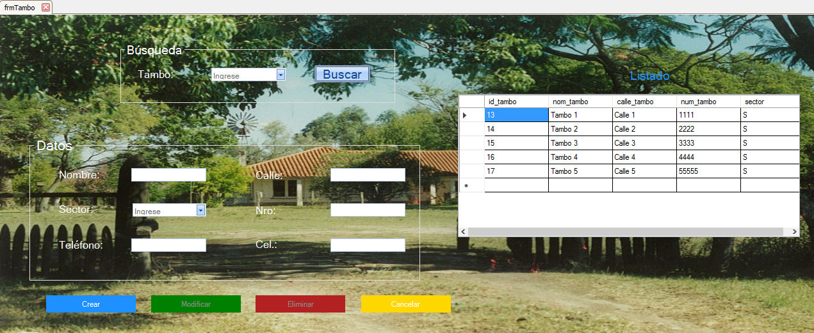

Código fuente:

Public Class frmTambo

Dim idtambo As Integer

Public Sub cargar_tambo()

sql = "select * from tambo"

Try

rs.Open(sql, cn)

cboBuscar.Items.Clear()

Catch ex As Exception

MsgBox("Error al buscar el Tambo.", MsgBoxStyle.Exclamation, "Atención")

Exit Sub

End Try

While Not rs.EOF

cboBuscar.Items.Add(rs("nom_tambo").Value)

rs.MoveNext()

End While

rs.Close()

End Sub

Public Sub cargargrilla()

sql = "select * from tambo"

Try

rs.Open(sql, cn)

Catch ex As Exception

MsgBox("No tiene ningun listado de tambos", MsgBoxStyle.Information, "Atención")

Exit Sub

End Try

If Not cargoGrilla(rs, DataGridView1) Then

MsgBox("No tiene ningun listado de tambos", MsgBoxStyle.Information, "Atención")

End If

rs.Close()

End Sub

Public Sub capturar_maximo()

sql = "select max (dbinfo('sqlca.sqlerrd1')) from tambo"

Try

rs.Open(sql, cn)

idtambo = rs(0).Value

rs.Close()

Catch ex As Exception

MsgBox("Ocurrió un error", MsgBoxStyle.Exclamation, "Error")

Exit Sub

End Try

End Sub

Public Sub inserto_tel()

sql = "insert into tel_tambo (id_tambo, tel_tambo) Values (" & idtambo & ",'" & txtTel.Text & "')"

Try

MsgBox(sql)

cn.Execute(sql)

Catch ex As Exception

MsgBox("Error al ingresar el registro", MsgBoxStyle.Exclamation, "Atención")

Exit Sub

End Try

End Sub

Public Sub inserto_cel()

sql = "insert into tel_tambo (id_tambo, tel_tambo) Values (" & idtambo & ",'" & txtCel.Text & "')"

Try

cn.Execute(sql)

Catch ex As Exception

MsgBox("Error al ingresar el registro", MsgBoxStyle.Exclamation, "Atención")

Exit Sub

End Try

End Sub

Public Sub Limpiar()

cboBuscar.Text = ""

txtNombre.Text = ""

cboSector.Text = ""

txtTel.Text = ""

txtCalle.Text = ""

txtNro.Text = ""

txtCel.Text = ""

btnCrear.Enabled = True

btnModificar.Enabled = False

btnEliminar.Enabled = False

End Sub

Private Sub btnCerrar_Click(sender As System.Object, e As System.EventArgs) Handles btnCerrar.Click

Me.Close()

End Sub

Private Sub frmTambo_Load(sender As System.Object, e As System.EventArgs) Handles MyBase.Load

gpoDatos.Enabled = True

btnModificar.Enabled = False

btnEliminar.Enabled = False

cargar_tambo()

cargargrilla()

End Sub

Private Sub btnCrear_Click(sender As System.Object, e As System.EventArgs) Handles btnCrear.Click

sql = "insert into tambo (nom_tambo, calle_tambo, num_tambo, sector) Values ('" & txtNombre.Text & "','" & txtCalle.Text & "'," & txtNro.Text & ",'" & cboSector.Text & "')"

Try

MsgBox(sql)

cn.Execute(sql)

Catch ex As Exception

MsgBox("No se pudo conectar con la Base de Datos.", MsgBoxStyle.Exclamation, "Error")

Exit Sub

End Try

capturar_maximo()

'Inserto Tel

If txtTel.Text <> "" Then

inserto_tel()

End If

'Inserto Cel

If txtCel.Text <> "" Then

inserto_cel()

End If

MsgBox("Usuario registrado correctamente.", MsgBoxStyle.Information, "Atención")

Limpiar()

cargar_tambo()

cargargrilla()

End Sub

Private Sub btnEliminar_Click(sender As System.Object, e As System.EventArgs) Handles btnEliminar.Click

sql = "delete from tel_tambo where id_tambo=(select id_tambo from tambo where nom_tambo='" & cboBuscar.Text & "')"

Try

If MsgBox("¿Está seguro que desea eliminar el tambo y sus registros?", MsgBoxStyle.YesNo) = MsgBoxResult.Yes Then

cn.Execute(sql)

End If

Catch ex As Exception

MsgBox("No se pudo conectar con la Base de Datos.", MsgBoxStyle.Exclamation, "Error")

Exit Sub

End Try

sql = "delete from tambo where nom_tambo='" & cboBuscar.Text & "'"

Try

cn.Execute(sql)

MsgBox("Usuario eliminado con éxito", MsgBoxStyle.Information, "Atención")

Catch ex As Exception

MsgBox("No se pudo conectar con la Base de Datos.", MsgBoxStyle.Exclamation, "Error")

Exit Sub

End Try

Limpiar()

cargar_tambo()

cargargrilla()

End Sub

Private Sub btnModificar_Click(sender As System.Object, e As System.EventArgs) Handles btnModificar.Click

sql = "update tel_tambo set tel_tambo='" & txtTel.Text & "') where id_tambo=(select id_tambo from tambo where nom_tambo='" & cboBuscar.Text & "')"

Try

cn.Execute(sql)

Catch ex As Exception

End Try

sql = "update tambo set nom_tambo='" & txtNombre.Text & "', calle_tambo='" & txtCalle.Text & "', num_tambo=" & txtNro.Text & ", sector='" & cboSector.Text & "' where nom_tambo='" & cboBuscar.Text & "'"

Try

cn.Execute(sql)

MsgBox("Modificación exitosa", MsgBoxStyle.Information, "Atención")

Catch ex As Exception

MsgBox("Se produjo un error", MsgBoxStyle.Exclamation, "Atención")

Exit Sub

End Try

Limpiar()

cargar_tambo()

cargargrilla()

End Sub

Private Sub btnBuscar_Click(sender As System.Object, e As System.EventArgs) Handles btnBuscar.Click

sql = "select * from tambo where nom_tambo='" & cboBuscar.Text & "'"

'; select * from tel_tambo where id_tambo=(select * from tambo where nom_tambo='" & cboBuscar.Text & "')

Try

rs.Open(sql, cn)

Catch ex As Exception

MsgBox("Error al buscar el Usuario.", MsgBoxStyle.Exclamation, "Atención")

Exit Sub

End Try

If rs.RecordCount = 1 Then

txtNombre.Text = rs("nom_tambo").Value

cboSector.Text = rs("sector").Value

txtCalle.Text = rs("calle_tambo").Value

txtNro.Text = rs("num_tambo").Value

'txtTel.Text = rs("tel_tambo").Value

btnCrear.Enabled = False

btnModificar.Enabled = True

btnEliminar.Enabled = True

Else

MsgBox("No se encontró el usuario.", MsgBoxStyle.Exclamation, "Atención")

End If

rs.Close()

End Sub

Private Sub btnCancelar_Click(sender As System.Object, e As System.EventArgs) Handles btnCancelar.Click

Limpiar()

End Sub

End Class

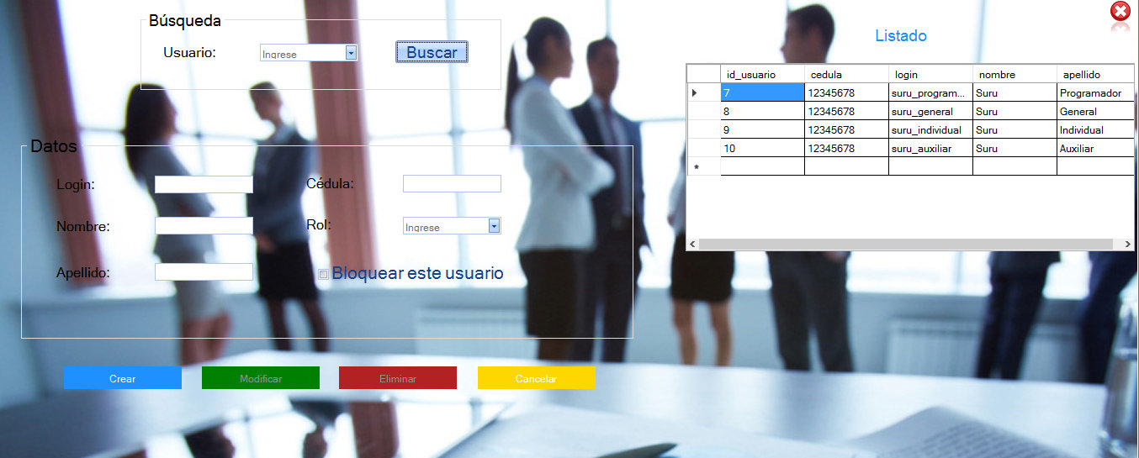Usuarios - frmUsuario.vb

Código fuente:

Imports System.Xml

Public Class frmUsuario

Dim roles(4) As Integer

Public Sub cargar_usuarios()

sql = "select * from usuario"

Try

rs.Open(sql, cn)

cboBuscar.Items.Clear()

Catch ex As Exception

MsgBox("Error al buscar el Usuario.", MsgBoxStyle.Exclamation, "Atención")

Exit Sub

End Try

While Not rs.EOF

cboBuscar.Items.Add(rs("login").Value)

rs.MoveNext()

End While

rs.Close()

End Sub

Public Sub cargar_rol()

Dim i As Integer = 0

sql = "select * from rol"

Try

rs.Open(sql, cn)

cboRol.Items.Clear()

Catch ex As Exception

MsgBox("Error al buscar el Usuario.", MsgBoxStyle.Exclamation, "Atención")

Exit Sub

End Try

While Not rs.EOF

cboRol.Items.Add(rs("nombre").Value)

roles(i) = rs("id_rol").Value

i = i + 1

rs.MoveNext()

End While

rs.Close()

End Sub

Public Sub cargargrilla()

sql = "select * from usuario"

Try

rs.Open(sql, cn)

Catch ex As Exception

MsgBox("err")

Exit Sub

End Try

If Not cargoGrilla(rs, DataGridView1) Then

MsgBox("No se pudo cargar grilla")

End If

rs.Close()

End Sub

Public Sub Limpiar()

cboBuscar.Text = ""

txtNombre.Text = ""

txtApellido.Text = ""

txtCedula.Text = ""

txtLogin.Text = ""

cboRol.Text = ""

optBloquear.Checked = False

btnCrear.Enabled = True

btnModificar.Enabled = False

btnEliminar.Enabled = False

End Sub

Private Sub frmUsuario_Load(ByVal sender As System.Object, ByVal e As System.EventArgs) Handles MyBase.Load

'Dim i As Integer = 0

gpoDatos.Enabled = True

btnModificar.Enabled = False

btnEliminar.Enabled = False

cargar_usuarios()

cargar_rol()

cargarGrilla()

End Sub

Private Sub btnCerrar_Click(sender As System.Object, e As System.EventArgs) Handles btnCerrar.Click

Me.Close()

End Sub

Private Sub btnBuscar_Click_2(sender As System.Object, e As System.EventArgs) Handles btnBuscar.Click

sql = "select u.*, rol.nombre as nombrerol from usuario u, usu_rol ur, rol where u.id_usuario=ur.id_usuario and ur.id_rol=rol.id_rol and login='" & cboBuscar.Text & "'"

Try

rs.Open(sql, cn)

Catch ex As Exception

MsgBox("Error al buscar el Usuario.", MsgBoxStyle.Exclamation, "Atención")

Exit Sub

End Try

If rs.RecordCount = 1 Then

txtCedula.Text = rs("cedula").Value

txtLogin.Text = rs("login").Value

txtNombre.Text = rs("nombre").Value

txtApellido.Text = rs("apellido").Value

cboRol.SelectedItem = rs("nombrerol").Value

btnCrear.Enabled = False

btnModificar.Enabled = True

btnEliminar.Enabled = True

Else

MsgBox("No se encontró el usuario.", MsgBoxStyle.Exclamation, "Atención")

End If

rs.Close()

End Sub

Private Sub btnCancelar_Click_1(sender As System.Object, e As System.EventArgs) Handles btnCancelar.Click

Limpiar()

End Sub

Private Sub btnAceptar_Click_1(sender As System.Object, e As System.EventArgs) Handles btnCrear.Click

Dim idusu As Integer

sql = "insert into usuario (cedula, login, nombre, apellido) Values (" & txtCedula.Text & ",'" & txtLogin.Text & "','" & txtNombre.Text & "','" & txtApellido.Text & "')"

Try

cn.Execute(sql)

Catch ex As Exception

MsgBox("No se pudo conectar con la Base de Datos.", MsgBoxStyle.Exclamation, "Error")

Exit Sub

End Try

sql = "select max (dbinfo('sqlca.sqlerrd1')) from usuario"

Try

rs.Open(sql, cn)

idusu = rs(0).Value

rs.Close()

Catch ex As Exception

MsgBox("Ocurrió un error", MsgBoxStyle.Exclamation, "Error")

Exit Sub

End Try

sql = "insert into usu_rol (id_usuario, id_rol) Values (" & idusu & "," & roles(cboRol.SelectedIndex) & ")"

Try

cn.Execute(sql)

MsgBox("Usuario registrado correctamente.", MsgBoxStyle.Information, "Atención")

Catch ex As Exception

MsgBox(sql + ex.ToString)

Exit Sub

End Try

Limpiar()

cargar_usuarios()

cargar_rol()

cargargrilla()

End Sub

Private Sub txtCedula_KeyPress(sender As Object, e As System.Windows.Forms.KeyPressEventArgs) Handles txtCedula.KeyPress

'TextBox solo numeros

validonumero(e)

End Sub

Private Sub txtCedula_TextChanged(sender As System.Object, e As System.EventArgs) Handles txtCedula.TextChanged

End Sub

Private Sub btnEliminar_Click(sender As System.Object, e As System.EventArgs) Handles btnEliminar.Click

sql = "delete from usu_rol where id_usuario=(select id_usuario from usuario where login='" & cboBuscar.Text & "')"

Try

If MsgBox("¿Está seguro que desea eliminar el usuario?", MsgBoxStyle.YesNo) = MsgBoxResult.Yes Then

cn.Execute(sql)

End If

Catch ex As Exception

MsgBox("No se pudo conectar con la Base de Datos.", MsgBoxStyle.Exclamation, "Error")

Exit Sub

End Try

sql = "delete from usuario where login='" & cboBuscar.Text & "'"

Try

cn.Execute(sql)

MsgBox("Usuario eliminado con éxito", MsgBoxStyle.Information, "Atención")

Catch ex As Exception

MsgBox("No se pudo conectar con la Base de Datos.", MsgBoxStyle.Exclamation, "Error")

Exit Sub

End Try

Limpiar()

cargar_usuarios()

cargar_rol()

cargargrilla()

End Sub

Private Sub btnModificar_Click(sender As System.Object, e As System.EventArgs) Handles btnModificar.Click

sql = "update usu_rol set id_rol= (select id_rol from rol where nombre='" & cboRol.Text & "') where id_usuario=(select id_usuario from usuario where login='" & txtLogin.Text & "')"

Try

cn.Execute(sql)

Catch ex As Exception

End Try

sql = "update usuario set cedula=" & txtCedula.Text & ", login='" & txtLogin.Text & "', nombre='" & txtNombre.Text & "', apellido='" & txtApellido.Text & "' where login='" & cboBuscar.Text & "'"

Try

cn.Execute(sql)

MsgBox("Modificación exitosa", MsgBoxStyle.Information, "Atención")

Catch ex As Exception

MsgBox("Se produjo un error", MsgBoxStyle.Exclamation, "Atención")

Exit Sub

End Try

Limpiar()

cargar_usuarios()

cargar_rol()

cargargrilla()

End Sub

End Class

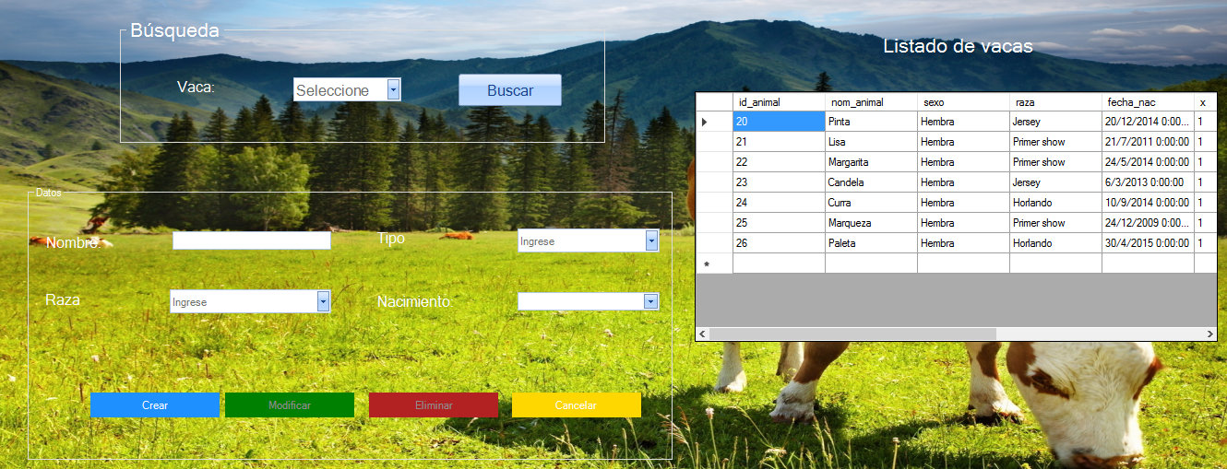Vacas - frmVaca.vb

Código fuente:

Public Class frmVaca

Dim Hembra As String

Public Sub cargar_vaca()

sql = "select * from vaca, animal where id_vaca=id_animal and x=1"

Try

rs.Open(sql, cn)

cboBuscar.Items.Clear()

Catch ex As Exception

MsgBox("Ocurrió un error.", MsgBoxStyle.Exclamation, "Atención")

Exit Sub

End Try

While Not rs.EOF

cboBuscar.Items.Add(rs("id_vaca").Value)

rs.MoveNext()

End While

rs.Close()

End Sub

Public Sub cargargrilla()

sql = "select * from animal,vaca where id_animal=id_vaca and x=1"

Try

rs.Open(sql, cn)

Catch ex As Exception

MsgBox("No se pudo cargar el listado de vacas")

Exit Sub

End Try

If Not cargoGrilla(rs, DataGridView1) Then

MsgBox("No se pudo cargar el listado de animales")

End If

rs.Close()

End Sub

Public Sub Limpiar()

cboBuscar.Text = ""

txtNombre.Text = ""

dateNacimiento.Text = ""

cboTipo.Text = ""

cboRaza.Text = ""

btnCrear.Enabled = True

btnModificar.Enabled = False

btnEliminar.Enabled = False

End Sub

Public Sub Estado2()

btnCrear.Enabled = False

btnModificar.Enabled = True

btnEliminar.Enabled = True

End Sub

Private Sub btnVolver_Click(sender As System.Object, e As System.EventArgs)

Me.Close()

End Sub

Private Sub ReflectionImage1_Click(sender As System.Object, e As System.EventArgs) Handles btnCerrar.Click

Me.Close()

End Sub

Private Sub ButtonX1_Click(sender As System.Object, e As System.EventArgs) Handles btnEliminar.Click

sql = "delete from vaca where id_vaca=" & Val(cboBuscar.Text)

Try

If MsgBox("¿Está seguro que desea eliminar el registro?", MsgBoxStyle.YesNo) = MsgBoxResult.Yes Then

cn.Execute(sql)

End If

Catch ex As Exception

MsgBox("No se pudo conectar con la Base de Datos.", MsgBoxStyle.Exclamation, "Error")

Exit Sub

End Try

sql = "delete from animal where id_animal=" & Val(cboBuscar.Text)

Try

cn.Execute(sql)

MsgBox("Animal eliminado del registro.", MsgBoxStyle.Information, "Atención")

Limpiar()

Catch ex As Exception

MsgBox("No se pudo conectar con la Base de Datos.", MsgBoxStyle.Exclamation, "Error")

Exit Sub

End Try

cargar_vaca()

cargargrilla()

btnCrear.Enabled = True

End Sub

Private Sub btnBuscar_Click(sender As System.Object, e As System.EventArgs) Handles btnBuscar.Click

btnCrear.Enabled = False

sql = "select * from animal where x=1 and id_animal=" & Val(cboBuscar.Text)

Try

rs.Open(sql, cn)

btnCrear.Enabled = False

Catch ex As Exception

MsgBox("Error al buscar el Animal.", MsgBoxStyle.Exclamation, "Atención")

btnCrear.Enabled = True

Exit Sub

End Try

If rs.RecordCount = 1 Then

txtNombre.Text = rs("nom_animal").Value

cboRaza.Text = rs("raza").Value

dateNacimiento.Value = rs("fecha_nac").Value

btnModificar.Enabled = True

btnEliminar.Enabled = True

Else

MsgBox("No se encontro el animal.", MsgBoxStyle.Exclamation, "Atención")

End If

rs.Close()

sql = "select * from vaca where id_vaca=" & Val(cboBuscar.Text)

Try

rs.Open(sql, cn)

Catch ex As Exception

Exit Sub

End Try

If rs.RecordCount = 1 Then

cboTipo.Text = rs("tipo").Value

Else

MsgBox("No se encontro el animal.", MsgBoxStyle.Exclamation, "Atención")

End If

rs.Close()

End Sub

Private Sub btnCrear_Click(sender As System.Object, e As System.EventArgs) Handles btnCrear.Click

Dim idvaca As Integer

sql = "insert into animal (nom_animal, sexo, raza, fecha_nac, x) Values ('" & _

txtNombre.Text & "','" & "Hembra" & "','" & cboRaza.Text & "','" & _

dateNacimiento.Value.ToString("dd/MM/yyyy") & "','" & 1 & "')"

Try

cn.Execute(sql)

Catch ex As Exception

MsgBox("No se pudo conectar con la Base de Datos.", MsgBoxStyle.Exclamation, "Error")

Exit Sub

End Try

sql = "select max (dbinfo('sqlca.sqlerrd1')) from animal"

Try

rs.Open(sql, cn)

idvaca = rs(0).Value

rs.Close()

Catch ex As Exception

MsgBox("Ocurrió un error", MsgBoxStyle.Exclamation, "Error")

Exit Sub

End Try

sql = "insert into vaca (id_vaca, tipo) Values (" & idvaca & ",'" & cboTipo.Text & "')"

Try

MsgBox("Animal guardado correctamente.", MsgBoxStyle.Information, "Atención")

cn.Execute(sql)

Limpiar()

Catch ex As Exception

Exit Sub

End Try

Limpiar()

cargar_vaca()

cargargrilla()

End Sub

Private Sub btnCancelar_Click_2(sender As System.Object, e As System.EventArgs) Handles btnCancelar.Click

Limpiar()

btnCrear.Enabled = True

End Sub

Private Sub frmVaca_Load(sender As System.Object, e As System.EventArgs) Handles MyBase.Load

btnModificar.Enabled = False

btnEliminar.Enabled = False

'sql = "select nom_animal from vaca, animal where id_vaca=id_animal"

cargar_vaca()

cargargrilla()

End Sub

Private Sub btnModificar_Click(sender As System.Object, e As System.EventArgs) Handles btnModificar.Click

sql = "update animal set nom_animal='" & txtNombre.Text & "', raza='" & cboRaza.Text & "' where id_animal=" & cboBuscar.Text & "; update vaca set tipo='" & cboTipo.Text & "' where id_vaca=" & cboBuscar.Text & ""

Try

cn.Execute(sql)

MsgBox("Modificación exitosa.", MsgBoxStyle.Information, "Atención")

Catch ex As Exception

MsgBox("No se pudo conectar con la Base de Datos.", MsgBoxStyle.Exclamation, "Error")

btnCrear.Enabled = True

Exit Sub

End Try

Limpiar()

btnCrear.Enabled = True

cargar_vaca()

cargargrilla()

End Sub

End Class

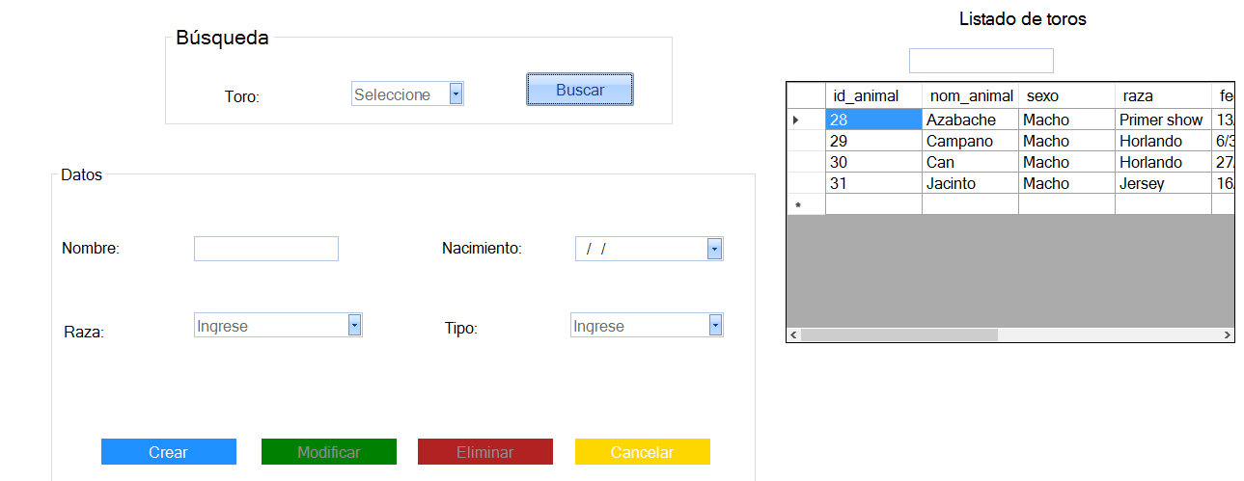Toros - frmToro.vb

Código fuente:

Public Class frmToro

Public Sub cargtoro()

sql = "select * from animal, toro where id_animal=id_toro and x=1"

Try

rs.Open(sql, cn)

cboBuscar.Items.Clear()

Catch ex As Exception

MsgBox("Error al buscar los datos.", MsgBoxStyle.Exclamation, "Atención")

Exit Sub

End Try

While Not rs.EOF

cboBuscar.Items.Add(rs("id_toro").Value)

rs.MoveNext()

End While

rs.Close()

End Sub

Public Sub cargar_toroo()

sql = "select nom_animal from toro, animal where id_toro=id_animal"

Try

rs.Open(sql, cn)

cboBuscar.Items.Clear()

Catch ex As Exception

MsgBox("Error al buscar el Usuario.", MsgBoxStyle.Exclamation, "Atención")

Exit Sub

End Try

While Not rs.EOF

cboBuscar.Items.Add(rs("nom_animal").Value)

rs.MoveNext()

End While

rs.Close()

End Sub

Public Sub cargargrilla()

sql = "select * from animal,toro where id_animal=id_toro and x=1"

Try

rs.Open(sql, cn)

Catch ex As Exception

MsgBox("No se pudo cargar el listado de vacas")

Exit Sub

End Try

If Not cargoGrilla(rs, DataGridView1) Then

MsgBox("No se pudo cargar el listado de animales")

End If

rs.Close()

End Sub

Public Sub filtrar()

sql = "select * from toro, animal where id_toro=id_animal and nom_animal=%like" & txtFIltrar.Text & ""

Try

rs.Open(sql, cn)

Catch ex As Exception

MsgBox("Error al buscar los datos.", MsgBoxStyle.Exclamation, "Atención")

Exit Sub

End Try

If Not cargoGrilla(rs, DataGridView1) Then

MsgBox("No se pudo cargar el listado de animales")

End If

rs.Close()

End Sub

Public Sub alertas(ByRef combo As ComboBox)

sql = "select * from animal where day(current) = day(fecha_nac) and month(current) = month(fecha_nac)"

End Sub

Public Sub limpiar()

cboBuscar.Text = ""

txtNombre.Text = ""

cboRaza.Text = ""

dateNacimiento.Text = ""

cboTipo.Text = ""

cboRaza.Text = ""

btnModificar.Enabled = False

btnEliminar.Enabled = False

End Sub

Private Sub ReflectionImage1_Click(sender As System.Object, e As System.EventArgs) Handles btnCerrar.Click

Me.Close()

End Sub

Private Sub ButtonX1_Click(sender As System.Object, e As System.EventArgs) Handles btnEliminar.Click

sql = "delete from toro where id_toro=" & Val(cboBuscar.Text)

Try

MsgBox(sql)

If MsgBox("¿Está seguro que desea eliminar el registro?", MsgBoxStyle.YesNo) = MsgBoxResult.Yes Then

cn.Execute(sql)

End If

Catch ex As Exception

MsgBox("No se pudo conectar con la Base de Datos1.", MsgBoxStyle.Exclamation, "Error")

btnCrear.Enabled = True

Exit Sub

End Try

sql = "delete from animal where id_animal=" & Val(cboBuscar.Text)

Try

cn.Execute(sql)

MsgBox("Animal eliminado del registro.", MsgBoxStyle.Information, "Atención")

btnModificar.Enabled = False

btnEliminar.Enabled = False

limpiar()

Catch ex As Exception

MsgBox("No se pudo conectar con la Base de Datos.", MsgBoxStyle.Exclamation, "Error")

btnCrear.Enabled = True

Exit Sub

End Try

btnCrear.Enabled = True

cargar_toroo()

cargargrilla()

End Sub

Private Sub ButtonX2_Click(sender As System.Object, e As System.EventArgs) Handles btnCrear.Click

Dim idtoro As Integer

sql = "insert into animal (nom_animal, sexo, raza, fecha_nac, x) Values ('" & _

txtNombre.Text & "','" & "Macho" & "','" & cboRaza.Text & "','" & _

dateNacimiento.Value.ToString("dd/MM/yyyy") & "'," & 1 & ")"

Try

MsgBox(sql)

cn.Execute(sql)

Catch ex As Exception

MsgBox("No se pudo conectar con la Base de Datos.", MsgBoxStyle.Exclamation, "Error")

Exit Sub

End Try

'Con lo siguiente capturaremos el último ID ingresado en la última tabla.

'Es decir, tomaremos el último ID ingresado en la tabla Animal para luego ingresar ese ID

'en la tabla Toro.

'Con eso logramos que la id_animal e id_toro coincidan.

sql = "select max (dbinfo('sqlca.sqlerrd1')) from animal"

Try

rs.Open(sql, cn)

idtoro = rs(0).Value

rs.Close()

Catch ex As Exception

MsgBox("Ocurrió un error", MsgBoxStyle.Exclamation, "Error")

Exit Sub

End Try

sql = "insert into toro (id_toro, tipo) Values (" & idtoro & ",'" & cboTipo.Text & "')"

Try

cn.Execute(sql)

MsgBox("Animal registrado correctamente.", MsgBoxStyle.Information, "Atención")

limpiar()

Catch ex As Exception

Exit Sub

End Try

cargar_toroo()

cargargrilla()

End Sub

Private Sub frmToro_Load(sender As System.Object, e As System.EventArgs) Handles MyBase.Load

btnModificar.Enabled = False

btnEliminar.Enabled = False

cargtoro()

cargargrilla()

End Sub

Private Sub btnBuscar_Click(sender As System.Object, e As System.EventArgs) Handles btnBuscar.Click

btnCrear.Enabled = False

sql = "select * from animal where x=1 and id_animal=" & Val(cboBuscar.Text)

Try

MsgBox(sql)

rs.Open(sql, cn)

Catch ex As Exception

MsgBox("Error al buscar el Animal.", MsgBoxStyle.Exclamation, "Atención")

Exit Sub

End Try

If rs.RecordCount = 1 Then

txtNombre.Text = rs("nom_animal").Value

cboRaza.Text = rs("raza").Value

dateNacimiento.Value = rs("fecha_nac").Value

btnModificar.Enabled = True

btnEliminar.Enabled = True

Else

MsgBox("No se encontro el animal.", MsgBoxStyle.Exclamation, "Atención")

btnCrear.Enabled = True

End If

rs.Close()

sql = "select * from toro where id_toro=" & Val(cboBuscar.Text)

Try

rs.Open(sql, cn)

Catch ex As Exception

Exit Sub

End Try

If rs.RecordCount = 1 Then

cboTipo.Text = rs("tipo").Value

Else

End If

rs.Close()

End Sub

Private Sub btnCancelar_Click(sender As System.Object, e As System.EventArgs) Handles btnCancelar.Click

limpiar()

btnCrear.Enabled = True

End Sub

Private Sub btnModificar_Click(sender As System.Object, e As System.EventArgs) Handles btnModificar.Click

sql = "update animal set nom_animal='" & txtNombre.Text & "', raza='" & cboRaza.Text & "' where id_animal=" & cboBuscar.Text & "; update toro set tipo='" & cboTipo.Text & "' where id_toro=" & cboBuscar.Text & ""

Try

cn.Execute(sql)

MsgBox("Modificación exitosa.", MsgBoxStyle.Information, "Atención")

btnCrear.Enabled = True

Catch ex As Exception

MsgBox("No se pudo conectar con la Base de Datos.", MsgBoxStyle.Exclamation, "Error")

Exit Sub

End Try

limpiar()

btnCrear.Enabled = True

cargar_toroo()

cargargrilla()

End Sub

End Class

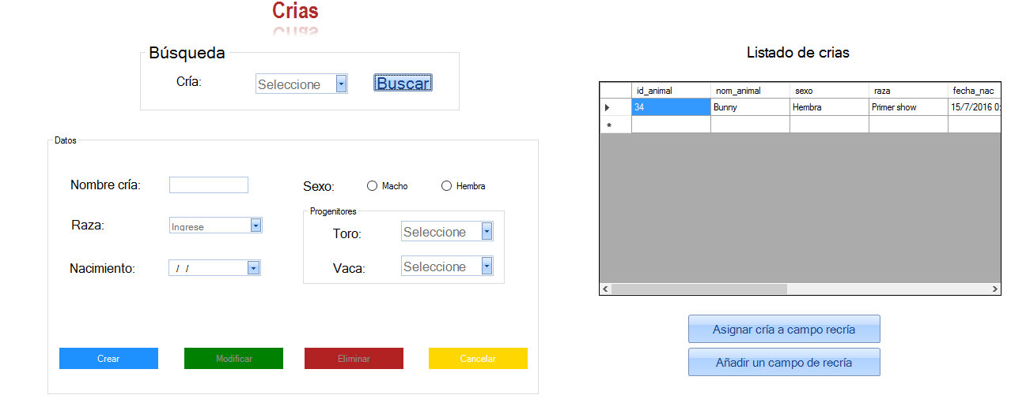Crías - frmCria.vb

Código fuente:

Public Class frmCria

Public Sub crear_cria_m()

Dim idcria As Integer

sql = "insert into animal (nom_animal, sexo, raza, fecha_nac, x) Values ('" & _

txtNombre.Text & "','" & "Macho" & "','" & cboRaza.Text & "','" & _

dateNacimiento.Value.ToString("dd/MM/yyyy") & "', " & 1 & ")"

Try

cn.Execute(sql)

Catch ex As Exception

MsgBox("No se pudo conectar con la Base de Datos.", MsgBoxStyle.Exclamation, "Error")

Exit Sub

End Try

'Con lo siguiente capturaremos el último ID ingresado en la última tabla.

'Es decir, tomaremos el último ID ingresado en la tabla Animal para luego ingresar ese ID

'en la tabla Cria.

'Con eso logramos que la id_animal e id_cria coincidan.

sql = "select max (dbinfo('sqlca.sqlerrd1')) from animal"

Try

rs.Open(sql, cn)

idcria = rs(0).Value

rs.Close()

Catch ex As Exception

MsgBox("Ocurrió un error", MsgBoxStyle.Exclamation, "Error")

Exit Sub

End Try

sql = "insert into cria (id_cria, id_toro, id_vaca) Values (" & idcria & "," & cboToro.Text & ",'" & cboVaca.Text & "')"

Try

cn.Execute(sql)

MsgBox("Cria registrada correctamente.", MsgBoxStyle.Information, "Atención")

limpiar()

Catch ex As Exception

Exit Sub

End Try

End Sub

Public Sub crear_cria_h()

Dim idcria As Integer

sql = "insert into animal (nom_animal, sexo, raza, fecha_nac, x) Values ('" & _

txtNombre.Text & "','" & "Hembra" & "','" & cboRaza.Text & "','" & _

dateNacimiento.Value.ToString("dd/MM/yyyy") & "', " & 1 & ")"

Try

cn.Execute(sql)

Catch ex As Exception

MsgBox("No se pudo conectar con la Base de Datos.", MsgBoxStyle.Exclamation, "Error")

Exit Sub

End Try

'Con lo siguiente capturaremos el último ID ingresado en la última tabla.

'Es decir, tomaremos el último ID ingresado en la tabla Animal para luego ingresar ese ID

'en la tabla Cria.

'Con eso logramos que la id_animal e id_cria coincidan.

sql = "select max (dbinfo('sqlca.sqlerrd1')) from animal"

Try

rs.Open(sql, cn)

idcria = rs(0).Value

rs.Close()

Catch ex As Exception

MsgBox("Ocurrió un error", MsgBoxStyle.Exclamation, "Error")

Exit Sub

End Try

sql = "insert into cria (id_cria, id_toro, id_vaca) Values (" & idcria & "," & cboToro.Text & ",'" & cboVaca.Text & "')"

Try

cn.Execute(sql)

MsgBox("Cria registrada correctamente.", MsgBoxStyle.Information, "Atención")

limpiar()

Catch ex As Exception

Exit Sub

End Try

End Sub

Public Sub cargar_toro()

sql = "select * from toro, animal where id_toro=id_animal and x=1"

Try

rs.Open(sql, cn)

cboToro.Items.Clear()

Catch ex As Exception

MsgBox("Error al buscar los datos.", MsgBoxStyle.Exclamation, "Atención")

Exit Sub

End Try

While Not rs.EOF

cboToro.Items.Add(rs("id_toro").Value)

rs.MoveNext()

End While

rs.Close()

End Sub

Public Sub cargar_vaca()

sql = "select * from vaca, animal where id_vaca=id_animal and x=1"

Try

rs.Open(sql, cn)

cboVaca.Items.Clear()

Catch ex As Exception

MsgBox("Ocurrió un error.", MsgBoxStyle.Exclamation, "Atención")

Exit Sub

End Try

While Not rs.EOF

cboVaca.Items.Add(rs("id_vaca").Value)

rs.MoveNext()

End While

rs.Close()

End Sub

Public Sub cargar_cria()

sql = "select * from cria"

Try

rs.Open(sql, cn)

cboBuscar.Items.Clear()

Catch ex As Exception

MsgBox("Error al buscar los datos.", MsgBoxStyle.Exclamation, "Atención")

Exit Sub

End Try

While Not rs.EOF

cboBuscar.Items.Add(rs("id_cria").Value)

rs.MoveNext()

End While

rs.Close()

End Sub

Public Sub cargargrilla()

sql = "select * from animal,cria where id_cria=id_animal and x=1"

Try

rs.Open(sql, cn)

Catch ex As Exception

MsgBox("No se pudo cargar el listado de crías")

Exit Sub

End Try

If Not cargoGrilla(rs, DataGridView1) Then

MsgBox("No se pudo cargar el listado de crías")

End If

rs.Close()

End Sub

Public Sub limpiar()

cboBuscar.Text = ""

txtNombre.Text = ""

cboRaza.Text = ""

dateNacimiento.Text = ""

btnModificar.Enabled = False

btnEliminar.Enabled = False

End Sub

Private Sub Button3_Click(ByVal sender As System.Object, ByVal e As System.EventArgs)

Me.Close()

End Sub

Private Sub ReflectionImage1_Click(sender As System.Object, e As System.EventArgs) Handles btnCerrar.Click

Me.Close()

End Sub

Private Sub frmCria_Load(sender As System.Object, e As System.EventArgs) Handles MyBase.Load

btnModificar.Enabled = False

btnEliminar.Enabled = False

cargar_toro()

cargar_vaca()

cargar_cria()

cargargrilla()

End Sub

Private Sub btnCancelar_Click(sender As System.Object, e As System.EventArgs)

End Sub

Private Sub btnBuscar_Click(sender As System.Object, e As System.EventArgs) Handles btnBuscar.Click

btnCrear.Enabled = False

sql = "select * from animal where id_animal=" & Val(cboBuscar.Text)

Try

rs.Open(sql, cn)

Catch ex As Exception

MsgBox("Error al buscar el Animal.", MsgBoxStyle.Exclamation, "Atención")

Exit Sub

End Try

If rs.RecordCount = 1 Then

txtNombre.Text = rs("nom_animal").Value

cboRaza.Text = rs("raza").Value

dateNacimiento.Value = rs("fecha_nac").Value

btnModificar.Enabled = True

btnEliminar.Enabled = True

Else

MsgBox("No se encontro el animal.", MsgBoxStyle.Exclamation, "Atención")

btnCrear.Enabled = True

End If

rs.Close()

sql = "select * from cria where id_cria=" & Val(cboBuscar.Text)

Try

rs.Open(sql, cn)

Catch ex As Exception

Exit Sub

End Try

If rs.RecordCount = 1 Then

Else

End If

rs.Close()

End Sub

Private Sub btnAceptar_Click(sender As System.Object, e As System.EventArgs)

End Sub

Private Sub ButtonX1_Click(sender As System.Object, e As System.EventArgs) Handles btnEliminar.Click

sql = "delete from cria where id_cria=" & Val(cboBuscar.Text)

Try

If MsgBox("¿Está seguro que desea eliminar el registro?", MsgBoxStyle.YesNo) = MsgBoxResult.Yes Then

cn.Execute(sql)

End If

Catch ex As Exception

MsgBox("No se pudo conectar con la Base de Datos.", MsgBoxStyle.Exclamation, "Error")

btnCrear.Enabled = True

Exit Sub

End Try

sql = "delete from animal where id_animal=" & Val(cboBuscar.Text)

Try

cn.Execute(sql)

MsgBox("Animal eliminado del registro.", MsgBoxStyle.Information, "Atención")

btnModificar.Enabled = False

btnEliminar.Enabled = False

limpiar()

Catch ex As Exception

MsgBox("No se pudo conectar con la Base de Datos.", MsgBoxStyle.Exclamation, "Error")

btnCrear.Enabled = True

Exit Sub

End Try

cargargrilla()

btnCrear.Enabled = True

End Sub

Private Sub btnCrear_Click(sender As System.Object, e As System.EventArgs) Handles btnCrear.Click

Dim idcria As Integer

If radMacho.Checked Then

crear_cria_m()

End If

If radHembra.Checked Then

crear_cria_h()

End If

cargargrilla()

End Sub

Private Sub btnCancelar_Click_1(sender As System.Object, e As System.EventArgs) Handles btnCancelar.Click

limpiar()

End Sub

Private Sub btnModificar_Click(sender As System.Object, e As System.EventArgs) Handles btnModificar.Click

sql = "update animal set nom_animal='" & txtNombre.Text & "', raza='" & cboRaza.Text & "' where id_animal=" & cboBuscar.Text & ""

Try

cn.Execute(sql)

MsgBox("Modificación exitosa.", MsgBoxStyle.Information, "Atención")

Catch ex As Exception

MsgBox("No se pudo conectar con la Base de Datos.", MsgBoxStyle.Exclamation, "Error")

btnCrear.Enabled = True

Exit Sub

End Try

limpiar()

btnCrear.Enabled = True

cargargrilla()

End Sub

Private Sub btnRecria1_Click(sender As System.Object, e As System.EventArgs) Handles btnRecria1.Click

frmRecria2.Show()

End Sub

Private Sub ButtonX2_Click(sender As System.Object, e As System.EventArgs) Handles ButtonX2.Click

frmRecria.MdiParent = frmMenu

frmRecria.Show()

End Sub

End Class

Navegación - frmNavegar.vb

Código fuente:

Public Class frmNavegar

Dim p As Integer = 1

Private Sub frmNavegar_Load(sender As System.Object, e As System.EventArgs) Handles MyBase.Load

Dim browse As New WebBrowser

TabControl1.TabPages.Add(p, "Página" & p)

TabControl1.SelectTab(p - 1)

browse.Name = "anjes"

browse.Dock = DockStyle.Fill

TabControl1.SelectedTab.Controls.Add(browse)

p = p + 1

End Sub

Private Sub ButtonX5_Click(sender As System.Object, e As System.EventArgs) Handles btnIr.Click

CType(TabControl1.SelectedTab.Controls.Item(0), WebBrowser).Navigate(txtUrl.Text)

End Sub

Private Sub ButtonX1_Click(sender As System.Object, e As System.EventArgs)

CType(TabControl1.SelectedTab.Controls.Item(0), WebBrowser).GoBack()

End Sub

Private Sub ButtonX2_Click(sender As System.Object, e As System.EventArgs)

CType(TabControl1.SelectedTab.Controls.Item(0), WebBrowser).GoForward()

End Sub

Private Sub ButtonX4_Click(sender As System.Object, e As System.EventArgs)

CType(TabControl1.SelectedTab.Controls.Item(0), WebBrowser).Refresh()

End Sub

Private Sub ButtonX3_Click(sender As System.Object, e As System.EventArgs)

Dim browse As New WebBrowser

TabControl1.TabPages.Add(p, "Página" & p)

TabControl1.SelectTab(p - 1)

browse.Name = "anjes"

browse.Dock = DockStyle.Fill

TabControl1.SelectedTab.Controls.Add(browse)

p = p + 1

End Sub

Private Sub btnUsuarios_Click(sender As System.Object, e As System.EventArgs) Handles btnRecargar.Click

CType(TabControl1.SelectedTab.Controls.Item(0), WebBrowser).Refresh()

End Sub

Private Sub Button1_Click(sender As System.Object, e As System.EventArgs) Handles btnAtras.Click

CType(TabControl1.SelectedTab.Controls.Item(0), WebBrowser).GoBack()

End Sub

Private Sub Button2_Click(sender As System.Object, e As System.EventArgs) Handles btnAdelante.Click

CType(TabControl1.SelectedTab.Controls.Item(0), WebBrowser).GoForward()

End Sub

Private Sub Button3_Click(sender As System.Object, e As System.EventArgs) Handles btnAdd.Click

Dim browse As New WebBrowser

TabControl1.TabPages.Add(p, "Página" & p)

TabControl1.SelectTab(p - 1)

browse.Name = "anjes"

browse.Dock = DockStyle.Fill

TabControl1.SelectedTab.Controls.Add(browse)

p = p + 1

End Sub

Private Sub ReflectionImage1_Click(sender As System.Object, e As System.EventArgs) Handles btnCerrar.Click

Me.Close()

End Sub

End Class

Enfermedades - frmEnfermedad.vb

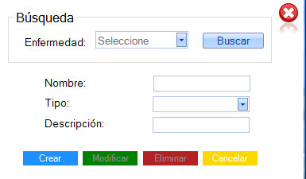

Public Class frmEnfermedad

Dim a As Integer

Public Sub cargar_enfermedad()

sql = "select * from enfermedad"

Try

rs.Open(sql, cn)

cboBuscar.Items.Clear()

Catch ex As Exception

MsgBox("Error al buscar.", MsgBoxStyle.Exclamation, "Atención")

Exit Sub

End Try

While Not rs.EOF

cboBuscar.Items.Add(rs("nombre").Value)

rs.MoveNext()

End While

rs.Close()

End Sub

Public Sub limpiar()

cboBuscar.Text = ""

txtNombre.Text = ""

cboTipo.Text = ""

txtDescripcion.Text = ""

btnModificar.Enabled = False

btnEliminar.Enabled = False

End Sub

Private Sub btnCerrar_Click(sender As System.Object, e As System.EventArgs) Handles btnCerrar.Click

Me.Close()

End Sub

Private Sub btnCrear_Click(sender As System.Object, e As System.EventArgs) Handles btnCrear.Click

sql = "insert into enfermedad (nombre, tipo, descrip) Values ('" & txtNombre.Text & "','" & cboTipo.Text & "','" & txtDescripcion.Text & "')"

Try

cn.Execute(sql)

MsgBox("Enfermedad registrada correctamente.", MsgBoxStyle.Information, "Atención")

limpiar()

Catch ex As Exception

MsgBox("No se pudo conectar con la Base de Datos.", MsgBoxStyle.Exclamation, "Error")

Exit Sub

End Try

cargar_enfermedad()

End Sub

Private Sub frmEnfermedad_Load(sender As System.Object, e As System.EventArgs) Handles MyBase.Load

btnModificar.Enabled = False

btnEliminar.Enabled = False

cargar_enfermedad()

End Sub

Private Sub btnEliminar_Click(sender As System.Object, e As System.EventArgs) Handles btnEliminar.Click

sql = "delete from enfermedad where nombre='" & (txtNombre.Text) & "'"

Try

If MsgBox("¿Está seguro que desea eliminar el registro?", MsgBoxStyle.YesNo) = MsgBoxResult.Yes Then

MsgBox(sql)

cn.Execute(sql)

MsgBox("Registro eliminado correctamente.", MsgBoxStyle.Information, "Atención")

btnModificar.Enabled = False

btnEliminar.Enabled = False

limpiar()

End If

Catch ex As Exception

MsgBox("No se pudo conectar con la Base de Datos.", MsgBoxStyle.Exclamation, "Error")

Exit Sub

End Try

cargar_enfermedad()

btnCrear.Enabled = True

End Sub

Private Sub btnCancelar_Click(sender As System.Object, e As System.EventArgs) Handles btnCancelar.Click

limpiar()

btnModificar.Enabled = False

btnEliminar.Enabled = False

End Sub

Private Sub btnModificar_Click(sender As System.Object, e As System.EventArgs) Handles btnModificar.Click

sql = "update enfermedad set nombre='" & txtNombre.Text & "', tipo='" & cboTipo.Text & "', descrip='" & txtDescripcion.Text & "' where nombre='" & cboBuscar.Text & "'"

Try

cn.Execute(sql)

MsgBox("Modificación exitosa.", MsgBoxStyle.Information, "Atención")

limpiar()

Catch ex As Exception

MsgBox("No se pudo conectar con la Base de Datos.", MsgBoxStyle.Exclamation, "Error")

Exit Sub

End Try

btnCrear.Enabled = True

End Sub

Private Sub btnBuscar_Click(sender As System.Object, e As System.EventArgs) Handles btnBuscar.Click

sql = "select * from enfermedad where nombre='" & cboBuscar.Text & "'"

Try

rs.Open(sql)

a = rs("id_enf").Value

Catch ex As Exception

MsgBox("err")

End Try

If rs.RecordCount = 1 Then

txtNombre.Text = rs("nombre").Value

cboTipo.Text = rs("tipo").Value

txtDescripcion.Text = rs("descrip").Value

btnCrear.Enabled = False

btnModificar.Enabled = True

btnEliminar.Enabled = True

Else

MsgBox("No se encontro lo solicitado.", MsgBoxStyle.Exclamation, "Atención")

End If

rs.Close()

End Sub

Private Sub cboBuscar_SelectedIndexChanged(sender As System.Object, e As System.EventArgs) Handles cboBuscar.SelectedIndexChanged

End Sub

End Class

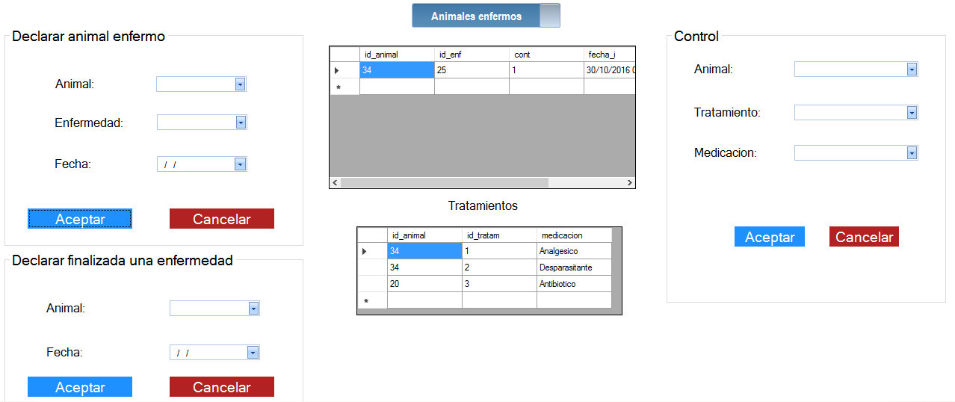Enfermedades/Tratamientos/Controles - frmContrae.vb

Código fuente:

Public Class frmContrae

Dim a As Integer

Dim b As Integer

Dim c As Integer

Public Sub cargar_animal()

sql = "select * from animal"

Try

rs.Open(sql, cn)

cboAnimal.Items.Clear()

cboAnimal2.Items.Clear()

Catch ex As Exception

MsgBox("Error al buscar los datos.", MsgBoxStyle.Exclamation, "Atención")

Exit Sub

End Try

While Not rs.EOF

cboAnimal.Items.Add(rs("id_animal").Value)

cboAnimal2.Items.Add(rs("id_animal").Value)

rs.MoveNext()

End While

rs.Close()

End Sub

Public Sub cargar_enfermedad()

sql = "select * from enfermedad"

Try

rs.Open(sql, cn)

cboEnf.Items.Clear()

Catch ex As Exception

MsgBox("Error al buscar.", MsgBoxStyle.Exclamation, "Atención")

Exit Sub

End Try

While Not rs.EOF

cboEnf.Items.Add(rs("nombre").Value)

rs.MoveNext()

End While

rs.Close()

End Sub

Public Sub cargar_tratamiento()

sql = "select * from tratamiento"

Try

rs.Open(sql, cn)

cboTratamiento.Items.Clear()

Catch ex As Exception

MsgBox("Error al buscar.", MsgBoxStyle.Exclamation, "Atención")

Exit Sub

End Try

While Not rs.EOF

cboTratamiento.Items.Add(rs("nombre").Value)

rs.MoveNext()

End While

rs.Close()

End Sub

Public Sub cargar_animal_enfermo()

sql = "select * from contrae where cont=1"

Try

rs.Open(sql, cn)

cboAnimal3.Items.Clear()

Catch ex As Exception

MsgBox("Error al buscar los datos.", MsgBoxStyle.Exclamation, "Atención")

Exit Sub

End Try

While Not rs.EOF

cboAnimal3.Items.Add(rs("id_animal").Value)

rs.MoveNext()

End While

rs.Close()

End Sub

Public Sub cargargrilla()

sql = "select * from contrae where cont=1"

Try

rs.Open(sql, cn)

Catch ex As Exception

MsgBox("Ocurrió un error al cargar los listados.", MsgBoxStyle.Exclamation, "Atención")

Exit Sub

End Try

If Not cargoGrilla(rs, DataGridView1) Then

MsgBox("No tiene ningún registro de animales enfermos", MsgBoxStyle.Information, "Atención")

End If

rs.Close()

End Sub

Public Sub cargargrilla2()

sql = "select * from contrae"

Try

rs.Open(sql, cn)

Catch ex As Exception

MsgBox("Ocurrió un error al cargar los listados.", MsgBoxStyle.Exclamation, "Atención")

Exit Sub

End Try

If Not cargoGrilla(rs, DataGridView3) Then

MsgBox("No tiene ningún registro guardado de animales que padecieron una enfermedad.", MsgBoxStyle.Information, "Atención")

End If

rs.Close()

End Sub

Public Sub cargargrilla_tratamiento()

sql = "select * from requiere"

Try

rs.Open(sql, cn)

Catch ex As Exception

MsgBox("Ocurrió un error al cargar los listados.", MsgBoxStyle.Exclamation, "Atención")

Exit Sub

End Try

If Not cargoGrilla(rs, DataGridView2) Then

MsgBox("No tiene ningún registro de animales que requieran tratamiento.", MsgBoxStyle.Information, "Atención")

End If

rs.Close()

End Sub

Public Sub limpiar()

cboAnimal.Text = ""

cboEnf.Text = ""

dateFecha.Text = ""

End Sub

Public Sub limpiar2()

cboAnimal2.Text = ""

cboTratamiento.Text = ""

cboMedicacion.Text = ""

End Sub

Private Sub btnAceptar_Click(sender As System.Object, e As System.EventArgs) Handles btnAceptar.Click

sql = "insert into contrae (id_animal, id_enf, fecha_i, cont) Values (" & cboAnimal.Text & "," & a & ",'" & dateFecha.Value.ToString("dd/MM/yyyy") & "'," & 1 & ")"

Try

cn.Execute(sql)

MsgBox("Registro guardado correctamente.", MsgBoxStyle.Information, "Atención")

limpiar()

Catch ex As Exception

MsgBox("No se pudo conectar con la Base de Datos.", MsgBoxStyle.Exclamation, "Error")

Exit Sub

End Try

cargargrilla()

End Sub

Private Sub frmEnf_Load(sender As System.Object, e As System.EventArgs) Handles MyBase.Load

cargar_animal()

cargar_enfermedad()

cargargrilla()

cargargrilla2()

cargar_tratamiento()

cargargrilla_tratamiento()

cargar_animal_enfermo()

End Sub

Private Sub btnCerrar_Click(sender As System.Object, e As System.EventArgs) Handles btnCerrar.Click

Me.Close()

End Sub

Private Sub btnCancelar_Click(sender As System.Object, e As System.EventArgs) Handles btnCancelar.Click

limpiar()

End Sub

Private Sub cboEnf_SelectedIndexChanged(sender As System.Object, e As System.EventArgs) Handles cboEnf.SelectedIndexChanged

sql = "select * from enfermedad where nombre='" & cboEnf.Text & "'"

Try

rs.Open(sql)

a = rs("id_enf").Value

Catch ex As Exception

MsgBox("Ocurrió un error", MsgBoxStyle.Exclamation, "Atención")

End Try

rs.Close()

End Sub

Private Sub cboTratamiento_SelectedIndexChanged(sender As System.Object, e As System.EventArgs) Handles cboTratamiento.SelectedIndexChanged

sql = "select * from tratamiento where nombre='" & cboTratamiento.Text & "'"

Try

rs.Open(sql)

b = rs("id_tratam").Value

Catch ex As Exception

MsgBox("Ocurrió un error", MsgBoxStyle.Exclamation, "Atención")

End Try

rs.Close()

End Sub

Private Sub ButtonX1_Click(sender As System.Object, e As System.EventArgs) Handles ButtonX1.Click

sql = "insert into requiere (id_animal, id_tratam, medicacion) Values (" & cboAnimal2.Text & "," & b & ",'" & cboMedicacion.Text & "')"

Try

cn.Execute(sql)

MsgBox("Registro guardado correctamente.", MsgBoxStyle.Information, "Atención")

limpiar()

Catch ex As Exception

MsgBox("Ocurrió un error.", MsgBoxStyle.Exclamation, "Atención")

Exit Sub

End Try

cargargrilla()

cargargrilla2()

cargargrilla_tratamiento()

End Sub

Private Sub SwitchButton1_ValueChanged(sender As System.Object, e As System.EventArgs) Handles SwitchButton1.ValueChanged

If SwitchButton1.Value = True Then

DataGridView1.Visible = True

DataGridView3.Visible = False

Else

DataGridView1.Visible = False

DataGridView3.Visible = True

End If

End Sub

Private Sub ButtonX2_Click(sender As System.Object, e As System.EventArgs) Handles ButtonX2.Click

limpiar2()

End Sub

Private Sub ButtonX3_Click(sender As System.Object, e As System.EventArgs) Handles ButtonX3.Click

sql = "update contrae set fecha_f='" & dateFechaF.Value.ToString("dd/MM/yyyy") & "', cont='" & 0 & "' where id_animal=" & cboAnimal3.Text & ""

Try

MsgBox(sql)

cn.Execute(sql)

MsgBox("Modificación exitosa.", MsgBoxStyle.Information, "Atención")

limpiar()

Catch ex As Exception

MsgBox("No se pudo conectar con la Base de Datos.", MsgBoxStyle.Exclamation, "Error")

Exit Sub

End Try

cargargrilla()

cboAnimal3.Text = ""

dateFechaF.Text = ""

End Sub

Private Sub cboAnimal2_SelectedIndexChanged(sender As System.Object, e As System.EventArgs) Handles cboAnimal2.SelectedIndexChanged

End Sub

Private Sub cboAnimal3_SelectedIndexChanged(sender As System.Object, e As System.EventArgs) Handles cboAnimal3.SelectedIndexChanged

End Sub

End Class

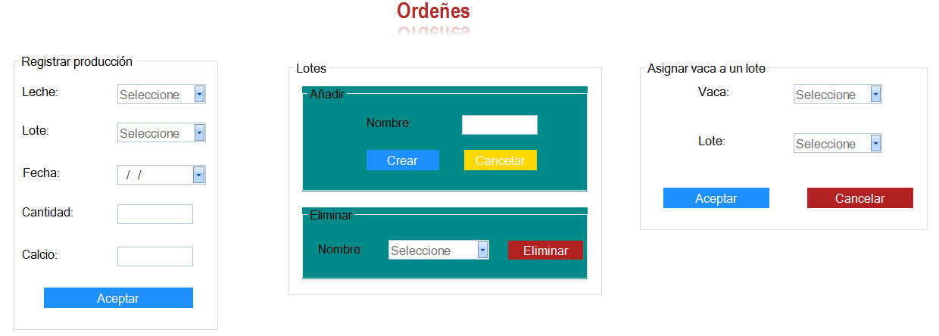Producción/Ordeñes - frmOrdenie.vb

Código fuente:

Public Class frmOrdenie

Dim a, b As Integer

Public Sub cargar_lote()

sql = "select * from lote"

Try

rs.Open(sql, cn)

cboLote.Items.Clear()

cboELiminarLote.Items.Clear()

cboIngresarLote.Items.Clear()

Catch ex As Exception

MsgBox("Error al buscar los datos.", MsgBoxStyle.Exclamation, "Atención")

Exit Sub

End Try

While Not rs.EOF

cboLote.Items.Add(rs("nombre").Value)

cboELiminarLote.Items.Add(rs("nombre").Value)

cboIngresarLote.Items.Add(rs("nombre").Value)

rs.MoveNext()

End While

rs.Close()

End Sub

Public Sub cargar_vaca()

sql = "select * from vaca"

Try

rs.Open(sql, cn)

cboVaca.Items.Clear()

Catch ex As Exception

MsgBox("Error al buscar los datos.", MsgBoxStyle.Exclamation, "Atención")

Exit Sub

End Try

While Not rs.EOF

cboVaca.Items.Add(rs("id_vaca").Value)

rs.MoveNext()

End While

rs.Close()

End Sub

Public Sub cargar_leche()

sql = "select * from leche"

Try

rs.Open(sql, cn)

cbolIngresarLeche.Items.Clear()

Catch ex As Exception

MsgBox("Error al buscar los datos.", MsgBoxStyle.Exclamation, "Atención")

Exit Sub

End Try

While Not rs.EOF

cbolIngresarLeche.Items.Add(rs("tipo").Value)

rs.MoveNext()

End While

rs.Close()

End Sub

Private Sub btnVolver_Click(sender As System.Object, e As System.EventArgs)

Me.Close()

End Sub

Private Sub ReflectionImage1_Click(sender As System.Object, e As System.EventArgs) Handles btnCerrar.Click

Me.Close()

End Sub

Private Sub frmOrdenie_Load(sender As System.Object, e As System.EventArgs) Handles MyBase.Load

cargar_vaca()

cargar_lote()

cargar_leche()

End Sub

Private Sub ButtonX4_Click(sender As System.Object, e As System.EventArgs) Handles ButtonX4.Click

sql = "insert into producen (id_lote, id_leche, cantidad, calcio, fecha) Values (" & a & ", " & cbolIngresarLeche.Text & ", " & txtCantidad.Text & ", " & txtCalcio.Text & ", '" & dateFecha.Value.ToString("dd/MM/yyyy") & "')"

Try

MsgBox(sql)

cn.Execute(sql)

MsgBox("Campo de recría registrada correctamente.", MsgBoxStyle.Information, "Atención")

Catch ex As Exception

MsgBox("No se pudo conectar con la Base de Datos.", MsgBoxStyle.Exclamation, "Error")

Exit Sub

End Try

End Sub

Private Sub cboIngresarLote_SelectedIndexChanged(sender As System.Object, e As System.EventArgs) Handles cboIngresarLote.SelectedIndexChanged

sql = "select * from lote where nombre='" & cboIngresarLote.Text & "'"

Try

rs.Open(sql)

a = rs("id_lote").Value

Catch ex As Exception

MsgBox("err")

End Try

rs.Close()

End Sub

Private Sub cboLote_SelectedIndexChanged(sender As System.Object, e As System.EventArgs) Handles cboLote.SelectedIndexChanged

sql = "select * from lote where nombre='" & cboLote.Text & "'"

Try

rs.Open(sql)

b = rs("id_lote").Value

Catch ex As Exception

MsgBox("err")

End Try

rs.Close()

End Sub

Private Sub btnCrear_Click(sender As System.Object, e As System.EventArgs) Handles btnCrear.Click

sql = "insert into lote (nombre) Values ('" & txtNombreLote.Text & "')"

Try

cn.Execute(sql)

MsgBox("Enfermedad registrada correctamente.", MsgBoxStyle.Information, "Atención")

Catch ex As Exception

MsgBox("No se pudo conectar con la Base de Datos.", MsgBoxStyle.Exclamation, "Error")

Exit Sub

End Try

cargar_lote()

End Sub

Private Sub btnEliminar_Click(sender As System.Object, e As System.EventArgs) Handles btnEliminar.Click

sql = "delete from lote where nombre='" & (cboELiminarLote.Text) & "'"

Try

If MsgBox("¿Está seguro que desea eliminar el registro?", MsgBoxStyle.YesNo) = MsgBoxResult.Yes Then

MsgBox(sql)

cn.Execute(sql)

MsgBox("Registro eliminado correctamente.", MsgBoxStyle.Information, "Atención")

End If

Catch ex As Exception

MsgBox("No se pudo conectar con la Base de Datos.", MsgBoxStyle.Exclamation, "Error")

Exit Sub

End Try

cargar_lote()

End Sub

Private Sub ButtonX2_Click(sender As System.Object, e As System.EventArgs) Handles ButtonX2.Click

sql = "insert into asigna (id_vaca, id_lote) Values (" & cboVaca.Text & ", " & b & ")"

Try

MsgBox(sql)

cn.Execute(sql)

MsgBox("Vaca asignada correctamente.", MsgBoxStyle.Information, "Atención")

Catch ex As Exception

MsgBox("No se pudo conectar con la Base de Datos.", MsgBoxStyle.Exclamation, "Error")

Exit Sub

End Try

End Sub

End Class

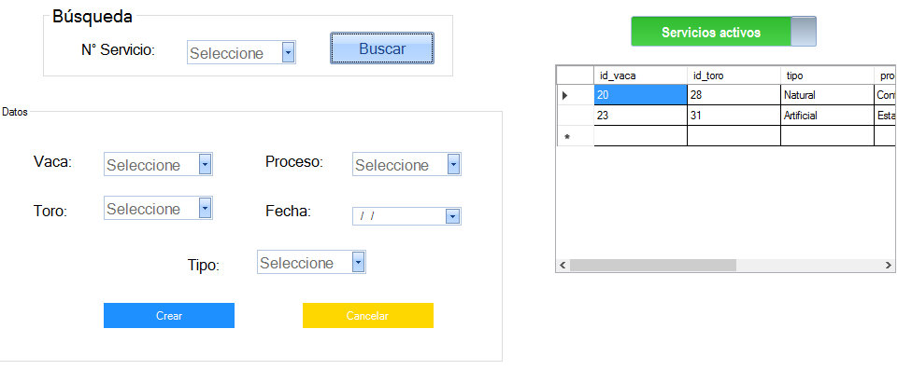Servicios/Entores - frmServicio.vb

Código fuente:

Public Class frmServicio

Public Sub cargar_vaca()

sql = "select * from vaca, animal where id_vaca=id_animal and x=1"

Try

rs.Open(sql, cn)

cboVaca.Items.Clear()

Catch ex As Exception

MsgBox("Ocurrió un error.", MsgBoxStyle.Exclamation, "Atención")

Exit Sub

End Try

While Not rs.EOF

cboVaca.Items.Add(rs("id_vaca").Value)

rs.MoveNext()

End While

rs.Close()

End Sub

Public Sub cargar_toro()

sql = "select * from toro, animal where id_toro=id_animal and x=1"

Try

rs.Open(sql, cn)

cboToro.Items.Clear()

Catch ex As Exception

MsgBox("Error al buscar los datos.", MsgBoxStyle.Exclamation, "Atención")

Exit Sub

End Try

While Not rs.EOF

cboToro.Items.Add(rs("id_toro").Value)

rs.MoveNext()

End While

rs.Close()

End Sub

Public Sub cargargrilla_servicioactivo()

sql = "select * from entora where servicio_activo=1"

Try

MsgBox(sql)

rs.Open(sql, cn)

Catch ex As Exception

MsgBox("err")

Exit Sub

End Try

If Not cargoGrilla(rs, DataGridView1) Then

MsgBox("No se pudo cargar grilla")

End If

rs.Close()

End Sub

Public Sub cargargrilla_servicio()

sql = "select * from entora"

Try

MsgBox(sql)

rs.Open(sql, cn)

Catch ex As Exception

MsgBox("err")

Exit Sub

End Try

If Not cargoGrilla(rs, DataGridView1) Then

MsgBox("No se pudo cargar grilla")

End If

rs.Close()

End Sub

Public Sub limpiar()

cboServicio.Text = ""

cboVaca.Text = ""

cboToro.Text = ""

cboTipo.Text = ""

cboProceso.Text = ""

dateEntore.Text = ""

End Sub

Private Sub btnCrear_Click(sender As System.Object, e As System.EventArgs) Handles btnCrear.Click

sql = "insert into entora (id_vaca, id_toro, tipo, proceso, fecha, servicio_activo) Values (" & cboVaca.Text & "," & cboToro.Text & ",'" & cboTipo.Text & "','" & cboProceso.Text & "','" & dateEntore.Value.ToString("dd/MM/yyyy") & "'," & 1 & ")"

Try

MsgBox(sql)

cn.Execute(sql)

Catch ex As Exception

MsgBox("No se pudo conectar con la Base de Datos.", MsgBoxStyle.Exclamation, "Error")

Exit Sub

End Try

End Sub

Private Sub frmServicio_Load(sender As System.Object, e As System.EventArgs) Handles MyBase.Load

1: cargar_vaca()

cargar_toro()

cargargrilla_servicioactivo()

cargargrilla_servicio()

End Sub

Private Sub btnCancelar_Click(sender As System.Object, e As System.EventArgs) Handles btnCancelar.Click

limpiar()

End Sub

Private Sub btnCerrar_Click(sender As System.Object, e As System.EventArgs) Handles btnCerrar.Click

Me.Close()

End Sub

Private Sub SwitchButton1_ValueChanged(sender As System.Object, e As System.EventArgs) Handles SwitchButton1.ValueChanged

If SwitchButton1.Value = True Then

DataGridView1.Visible = True

DataGridView2.Visible = False

Else

DataGridView1.Visible = False

DataGridView2.Visible = True

End If

End Sub

End Class

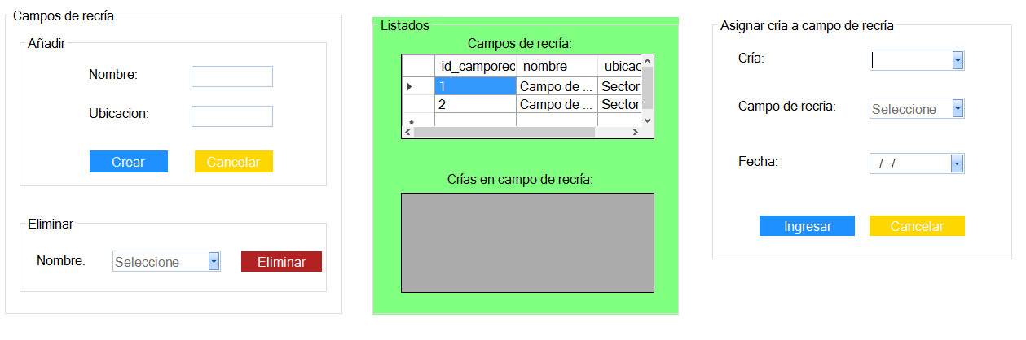Campos de recría - frmRecria.vb

Código fuente:

Public Class frmRecria

Dim camporecria As Integer

Public Sub cargar_camporecria()

sql = "select * from campo_recria"

Try

rs.Open(sql, cn)

cboBuscar.Items.Clear()

cboRecria.Items.Clear()

Catch ex As Exception

MsgBox("Error al buscar los datos.", MsgBoxStyle.Exclamation, "Atención")

Exit Sub

End Try

While Not rs.EOF

cboBuscar.Items.Add(rs("nombre").Value)

cboRecria.Items.Add(rs("nombre").Value)

rs.MoveNext()

End While

rs.Close()

End Sub

Public Sub cargargrilla()

sql = "select * from campo_recria"

Try

rs.Open(sql, cn)

Catch ex As Exception

MsgBox("No se pudo cargar el listado.", MsgBoxStyle.Information, "Atención")

Exit Sub

End Try

If Not cargoGrilla(rs, DataGridView1) Then

MsgBox("No se pudo cargar el listado.", MsgBoxStyle.Information, "Atención")

End If

rs.Close()

End Sub

Public Sub cargar_crias_en_camporecria()

sql = "select * from van"

Try

rs.Open(sql, cn)

Catch ex As Exception

MsgBox("No se pudo cargar el listado.", MsgBoxStyle.Information, "Atención")

Exit Sub

End Try

If Not cargoGrilla(rs, DataGridView2) Then

MsgBox("No se pudo cargar el listado.", MsgBoxStyle.Information, "Atención")

End If

rs.Close()

End Sub

Public Sub cargar_cria()

sql = "select * from cria"

Try

rs.Open(sql, cn)

cboCria.Items.Clear()

Catch ex As Exception

MsgBox("Error al buscar los datos.", MsgBoxStyle.Exclamation, "Atención")

Exit Sub

End Try

While Not rs.EOF

cboCria.Items.Add(rs("id_cria").Value)

rs.MoveNext()

End While

rs.Close()

End Sub

Public Sub limpiar()

txtRecria.Text = ""

txtUbicacion.Text = ""

End Sub

Private Sub frmRecria_Load(sender As System.Object, e As System.EventArgs) Handles MyBase.Load

cargar_camporecria()

cargargrilla()

cargar_crias_en_camporecria()

cargar_cria()

End Sub

Private Sub btnCrear_Click(sender As System.Object, e As System.EventArgs) Handles btnCrear.Click

sql = "insert into campo_recria (nombre, ubicacion) Values ('" & txtRecria.Text & "', '" & txtUbicacion.Text & "')"

Try

cn.Execute(sql)

MsgBox("Campo de recría registrada correctamente.", MsgBoxStyle.Information, "Atención")

Catch ex As Exception

MsgBox("No se pudo conectar con la Base de Datos.", MsgBoxStyle.Exclamation, "Error")

Exit Sub

End Try

limpiar()

cargar_camporecria()

cargargrilla()

End Sub

Private Sub btnEliminar_Click_1(sender As System.Object, e As System.EventArgs) Handles btnEliminar.Click

sql = "delete from van where id_camporec=(select * from campo_recria where nombre='" & cboBuscar.Text & "'); delete from campo_recria where nombre='" & (cboBuscar.Text) & "'"

Try

MsgBox(sql)

If MsgBox("¿Está seguro que desea eliminar el registro?", MsgBoxStyle.YesNo) = MsgBoxResult.Yes Then

cn.Execute(sql)

MsgBox("Registro eliminado correctamente.", MsgBoxStyle.Information, "Atención")

End If

Catch ex As Exception

MsgBox("No se pudo conectar con la Base de Datos.", MsgBoxStyle.Exclamation, "Error")

Exit Sub

End Try

cboBuscar.Text = ""

cargar_camporecria()

cargargrilla()

End Sub

Private Sub btnIngresar_Click(sender As System.Object, e As System.EventArgs) Handles btnIngresar.Click

sql = "insert into van (id_cria, id_camporec, fecha) Values (" & cboCria.Text & ", " & camporecria & ", '" & dateFecha.Value.ToString("dd/MM/yyyy") & "')"

Try

cn.Execute(sql)

MsgBox("Campo de recría registrada correctamente.", MsgBoxStyle.Information, "Atención")

Catch ex As Exception

MsgBox("No se pudo conectar con la Base de Datos.", MsgBoxStyle.Exclamation, "Error")

Exit Sub

End Try

cboCria.Text = ""

cboRecria.Text = ""

dateFecha.Text = ""

cargar_crias_en_camporecria()

End Sub

Private Sub cboRecria_SelectedIndexChanged(sender As System.Object, e As System.EventArgs) Handles cboRecria.SelectedIndexChanged

sql = "select * from campo_recria where nombre='" & cboRecria.Text & "'"

Try

rs.Open(sql)

camporecria = rs("id_camporec").Value

Catch ex As Exception

MsgBox("Ocurrió un error", MsgBoxStyle.Exclamation, "Atención")

End Try

rs.Close()

End Sub

End Class

Asignar campo de recía - frmRecria2.vb

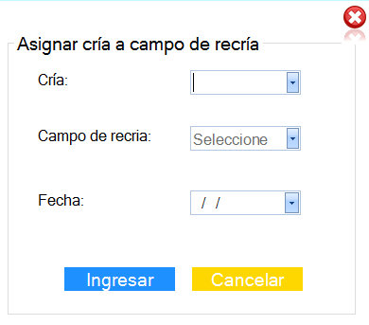

Código fuente:

Public Class frmRecria2

Dim camporecria As Integer

Public Sub cargar_camporecria()

sql = "select * from campo_recria"

Try

rs.Open(sql, cn)

cboRecria.Items.Clear()

Catch ex As Exception

MsgBox("Error al buscar los datos.", MsgBoxStyle.Exclamation, "Atención")

Exit Sub

End Try

While Not rs.EOF

cboRecria.Items.Add(rs("nombre").Value)

rs.MoveNext()

End While

rs.Close()

End Sub

Public Sub cargar_cria()

sql = "select * from cria"

Try

rs.Open(sql, cn)

cboCria.Items.Clear()

Catch ex As Exception

MsgBox("Error al buscar los datos.", MsgBoxStyle.Exclamation, "Atención")

Exit Sub

End Try

While Not rs.EOF

cboCria.Items.Add(rs("id_cria").Value)

rs.MoveNext()

End While

rs.Close()

End Sub

Private Sub btnIngresar_Click(sender As System.Object, e As System.EventArgs) Handles btnIngresar.Click

End Sub

Private Sub frmRecria2_Load(sender As System.Object, e As System.EventArgs) Handles MyBase.Load

cargar_camporecria()

cargar_cria()

End Sub

Private Sub cboRecria_SelectedIndexChanged(sender As System.Object, e As System.EventArgs) Handles cboRecria.SelectedIndexChanged

sql = "select * from campo_recria where nombre='" & cboRecria.Text & "'"

Try

rs.Open(sql)

camporecria = rs("id_camporec").Value

Catch ex As Exception

MsgBox("Ocurrió un error", MsgBoxStyle.Exclamation, "Atención")

End Try

rs.Close()

End Sub

Private Sub btnCerrar_Click(sender As System.Object, e As System.EventArgs) Handles btnCerrar.Click

Me.Close()

End Sub

End Class

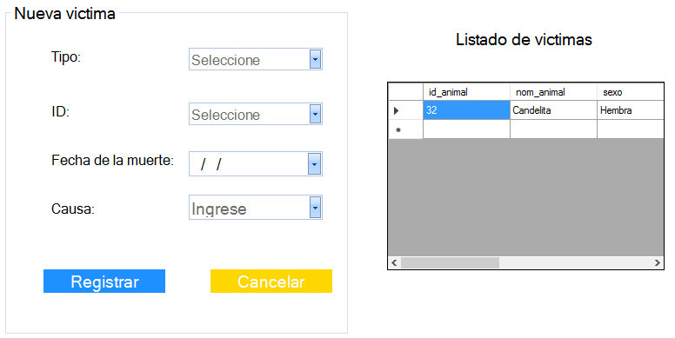Víctimas/Muertes - frmVíctima.vb

Código fuente:

Public Class frmVictima

Dim idanimal As Integer

Dim nom, sexo, raza, causa As String

Dim fechanac As String

Public Sub capturar_datos()

sql = "select * from animal where id_animal=" & Val(cboID.Text)

Try

rs.Open(sql, cn)

Catch ex As Exception

MsgBox("Error al buscar el Animal.", MsgBoxStyle.Exclamation, "Atención")

Exit Sub

End Try

If rs.RecordCount = 1 Then

idanimal = cboID.Text

nom = rs("nom_animal").Value

sexo = rs("sexo").Value

raza = rs("raza").Value

fechanac = rs("fecha_nac").Value

Else

MsgBox("No se encontro el animal.", MsgBoxStyle.Exclamation, "Atención")

End If

rs.Close()

sql = "update animal set x=" & 0 & " where id_animal=" & cboID.Text & ""

Try

cn.Execute(sql)

MsgBox("Modificación exitosa.", MsgBoxStyle.Information, "Atención")

Catch ex As Exception

MsgBox("No se pudo conectar con la Base de Datos.", MsgBoxStyle.Exclamation, "Error")

Exit Sub

End Try

sql = "update animal set fecha_muerte='" & dateMuerte.Value.ToString("dd/MM/yyyy") & "' where id_animal=" & cboID.Text & ""

Try

MsgBox(sql)

cn.Execute(sql)

MsgBox("Modificación exitosa.", MsgBoxStyle.Information, "Atención")

Catch ex As Exception

MsgBox("No se pudo conectar con la Base de Datos.", MsgBoxStyle.Exclamation, "Error")

Exit Sub

End Try

End Sub

Public Sub cargar_toro()

sql = "select * from toro, animal where id_toro=id_animal and x=1"

Try

rs.Open(sql, cn)

cboID.Items.Clear()

Catch ex As Exception

MsgBox("Error al buscar los datos.", MsgBoxStyle.Exclamation, "Atención")

Exit Sub

End Try

While Not rs.EOF

cboID.Items.Add(rs("id_toro").Value)

rs.MoveNext()

End While

rs.Close()

End Sub

Public Sub cargar_vaca()

sql = "select * from vaca, animal where id_vaca=id_animal and x=1"

Try

rs.Open(sql, cn)

cboID.Items.Clear()

Catch ex As Exception

MsgBox("Error al buscar los datos.", MsgBoxStyle.Exclamation, "Atención")

Exit Sub

End Try

While Not rs.EOF

cboID.Items.Add(rs("id_vaca").Value)

rs.MoveNext()

End While

rs.Close()

End Sub

Public Sub cargar_cria()

sql = "select * from cria, animal where id_cria=id_animal and x=1"

Try

rs.Open(sql, cn)

cboID.Items.Clear()

Catch ex As Exception

MsgBox("Error al buscar los datos.", MsgBoxStyle.Exclamation, "Atención")

Exit Sub

End Try

While Not rs.EOF

cboID.Items.Add(rs("id_cria").Value)

rs.MoveNext()

End While

rs.Close()

End Sub

Public Sub cargar_grilla()

sql = "select * from animal where x=0"

Try

rs.Open(sql, cn)

Catch ex As Exception

MsgBox("No se pudo cargar el listado de victimas")

Exit Sub

End Try

If Not cargoGrilla(rs, DataGridView1) Then

MsgBox("No se pudo cargar el listado de victimas")

End If

rs.Close()

End Sub

Public Sub limpiar()

cboID.Text = ""

dateMuerte.Text = ""

cboCausa.Text = ""

End Sub

Private Sub frmMuerte_Load(sender As System.Object, e As System.EventArgs) Handles MyBase.Load

cargar_grilla()

End Sub

Private Sub btnRegistrar_Click(sender As System.Object, e As System.EventArgs) Handles btnRegistrar.Click

capturar_datos()

End Sub

Private Sub cboTipo_SelectedIndexChanged(sender As System.Object, e As System.EventArgs) Handles cboTipo.SelectedIndexChanged

If cboTipo.Text = "Toro" Then

cargar_toro()

End If

If cboTipo.Text = "Vaca" Then

cargar_vaca()

End If

If cboTipo.Text = "Cria" Then

cargar_cria()

End If

End Sub

Private Sub gpoVictima_Enter(sender As System.Object, e As System.EventArgs) Handles gpoVictima.Enter

End Sub

End Class

Estados de una vaca - frmEstado.vb

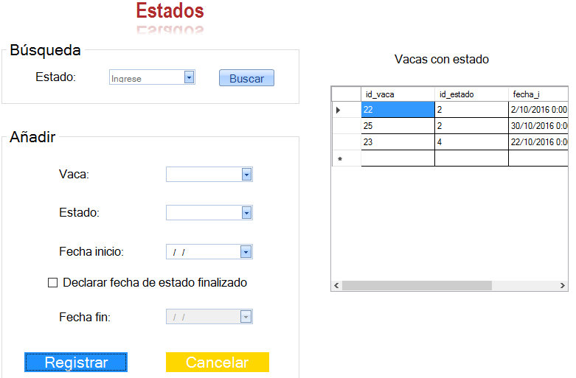

Código fuente:

Public Class frmEstado

Dim a As Integer

Public Sub crear_estado()

sql = "insert into tiene (id_vaca, id_estado, fecha_i) Values (" & cboVaca.Text & "," & a & ",'" & dateFechaI.Value.ToString("dd/MM/yyyy") & "')"

Try

cn.Execute(sql)

MsgBox("Registro guardado correctamente.", MsgBoxStyle.Information, "Atención")

limpiar()

Catch ex As Exception

MsgBox(ex.ToString)

MsgBox("No se pudo conectar con la Base de Datos.", MsgBoxStyle.Exclamation, "Error")

Exit Sub

End Try

cargargrilla_tiene()

End Sub

Public Sub crear_estado_fechafin()

sql = "insert into tiene (id_vaca, id_estado, fecha_i, fecha_f) Values (" & cboVaca.Text & "," & a & ",'" & dateFechaI.Value.ToString("dd/MM/yyyy") & "', '" & dateFechaF.Value.ToString("dd/MM/yyyy") & "')"

Try

cn.Execute(sql)

MsgBox("Registro guardado correctamente.", MsgBoxStyle.Information, "Atención")

limpiar()

Catch ex As Exception

MsgBox(ex.ToString)

MsgBox("No se pudo conectar con la Base de Datos.", MsgBoxStyle.Exclamation, "Error")

Exit Sub

End Try

cargargrilla_tiene()

End Sub

Public Sub cargar_estado()

sql = "select * from estado"

Try

rs.Open(sql, cn)

cboEstado.Items.Clear()

Catch ex As Exception

MsgBox("Error al buscar los datos.", MsgBoxStyle.Exclamation, "Atención")

Exit Sub

End Try

While Not rs.EOF

cboEstado.Items.Add(rs("nombre").Value)

rs.MoveNext()

End While

rs.Close()

End Sub

Public Sub cargar_vaca()

sql = "select * from vaca"

Try

rs.Open(sql, cn)

cboVaca.Items.Clear()

Catch ex As Exception

MsgBox("Error al buscar los datos.", MsgBoxStyle.Exclamation, "Atención")

Exit Sub

End Try

While Not rs.EOF

cboVaca.Items.Add(rs("id_vaca").Value)

rs.MoveNext()

End While

rs.Close()

End Sub

Public Sub cargar_tiene()

sql = "select * from tiene"

Try

rs.Open(sql, cn)

cboBuscar.Items.Clear()

Catch ex As Exception

MsgBox("Error al buscar los datos.", MsgBoxStyle.Exclamation, "Atención")

Exit Sub

End Try

While Not rs.EOF

cboBuscar.Items.Add(rs("id_estado").Value)

rs.MoveNext()

End While

rs.Close()

End Sub

Public Sub cargargrilla_tiene()

sql = "select * from tiene"

Try

rs.Open(sql, cn)

Catch ex As Exception

MsgBox("No se pudo cargar el listado debido a que no tiene registros.", MsgBoxStyle.Information, "Atención")

Exit Sub

End Try

If Not cargoGrilla(rs, DataGridView1) Then

MsgBox("No se pudo cargar el listado debido a que no tiene registros.", MsgBoxStyle.Information, "Atención")

End If

rs.Close()

End Sub

Public Sub limpiar()

cboBuscar.Text = ""

cboVaca.Text = ""

cboEstado.Text = ""

dateFechaI.Text = ""

dateFechaF.Text = ""

End Sub

Private Sub frmEstado_Load(sender As System.Object, e As System.EventArgs) Handles MyBase.Load

cargar_vaca()

cargar_estado()

cargar_tiene()

'cargargrilla_tiene()

End Sub

Private Sub btnRegistrar_Click(sender As System.Object, e As System.EventArgs) Handles btnRegistrar.Click

If chkDeclarar.Checked Then

crear_estado_fechafin()

Else

crear_estado()

End If

End Sub

Private Sub btnCerrar_Click(sender As System.Object, e As System.EventArgs) Handles btnCerrar.Click

Me.Close()

End Sub

Private Sub btnBuscar_Click(sender As System.Object, e As System.EventArgs) Handles btnBuscar.Click

End Sub

Private Sub cboEstado_SelectedIndexChanged(sender As System.Object, e As System.EventArgs) Handles cboEstado.SelectedIndexChanged

sql = "select * from estado where nombre='" & cboEstado.Text & "'"

Try

rs.Open(sql)

a = rs("id_estado").Value

MsgBox(a)

Catch ex As Exception

MsgBox("err")

End Try

rs.Close()

End Sub

Private Sub cboBuscar_SelectedIndexChanged(sender As System.Object, e As System.EventArgs) Handles cboBuscar.SelectedIndexChanged

End Sub

Private Sub CheckBox1_CheckedChanged(sender As System.Object, e As System.EventArgs) Handles chkDeclarar.CheckedChanged

If chkDeclarar.Checked Then

dateFechaF.Enabled = True

Else

dateFechaF.Enabled = False

End If

End Sub

End Class

Tutorial creación del instalador:

Para crear el instalador de nuestro programa, lo primero que debemos hacer es agregar un nuevo proyecto a la solución, éste será un proyecto de instalación de Visual Studio.

Se procede haciendo clic derecho sobre la solución, agregar nuevo proyecto. Dentro del panel derecho despliegamos 'Otros tipos de proyectos'/'Instalador de Visual Studio' y seleccionamos un Proyecto de instalación.

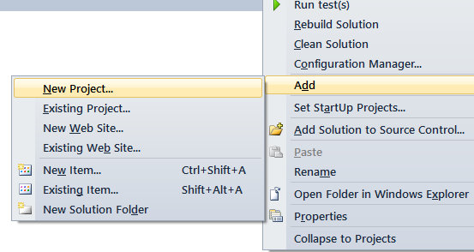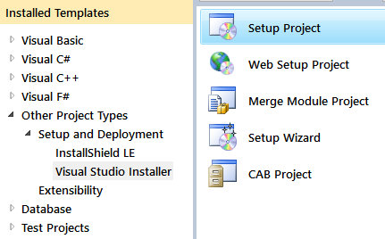

Si queremos que el usuario final no tenga acceso a nuestro código fuente debemos agregar un resultado al proyecto en la carpeta de aplicación.

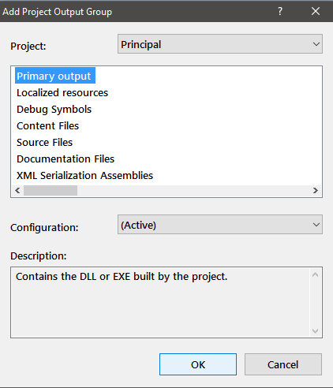Seleccionamos carpeta de la aplicación, en el panel derecho agregamos una carpeta e importamos el resultado principal.

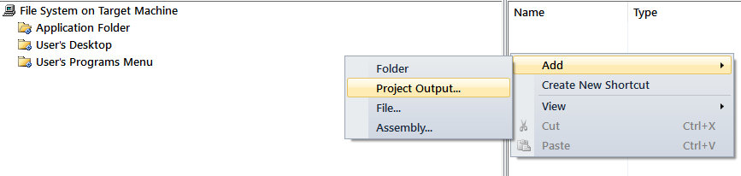

Lo siguiente que vamos a hacer será crear el acceso directo y asignarle un icono a nuestra aplicación.

Seleccionando la carpeta 'Escritorio del usuario', en el panel derecho haremos clic derecho y creamos un nuevo acceso directo. Seleccionamos nuestro resultado principal, y en la propiedad Icon, seleccionamos el icono que deseemos asignarle.

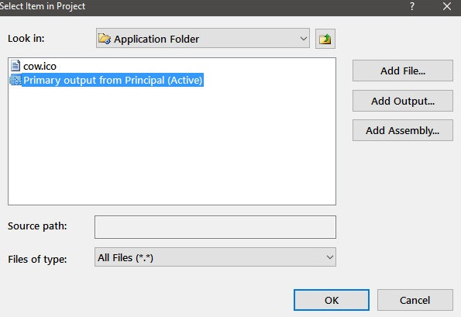

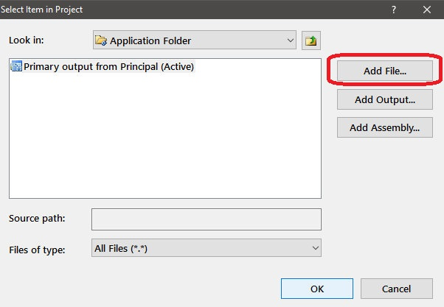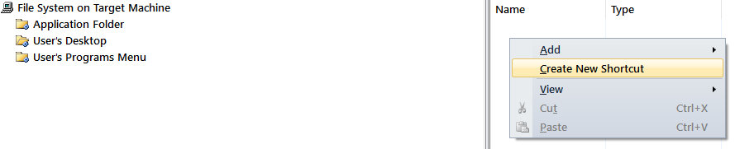

Si queremos crear además un acceso directo en el menú inicio repetimos el mismo proceso pero con la tercer carpeta 'Menú programas del usuario'.

Una vez configurado el instalador lo que debemos hacer es generar nuestro proyecto, haciendo clic derecho sobre el instalador - 'Generar'.

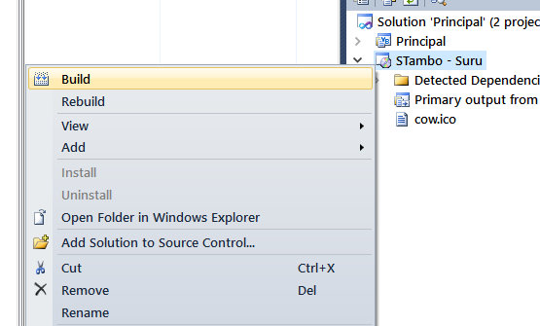

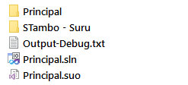Una vez finalizado este proceso, dentro de la misma carpeta donde tenemos el proyecto habrá una subcarpeta con nuestro instalador, en 'STambo - Suru' ejecutamos (setup.exe).

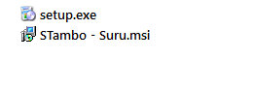

Al ejecutar el instalador se nos abre el asistente para la instalación de nuestro programa.

Se procede haciendo clic en 'Siguiente'

.

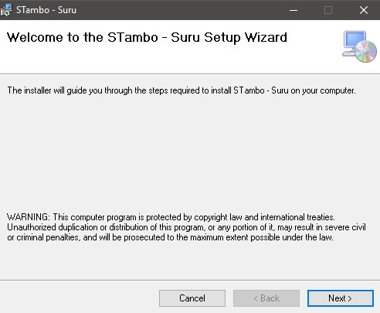

Nos muestra la ubicación donde se instalará el programa, esto se puede configurar haciendo clic en 'Examinar'.

Como podemos observar más abajo tendremos 2 opciones, una es para instalar nuestro programa para todos los usuarios del sistema, y la otra solo para el usuario quien ejecutó el instalador.

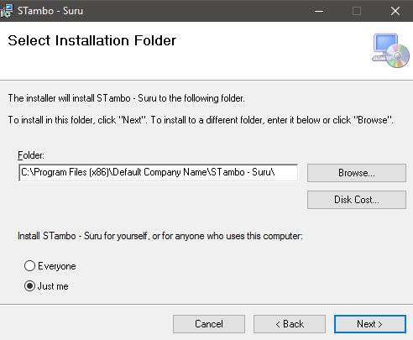Procederemos haciendo clic en 'Siguiente'.

Una vez todo listo haremos clic en 'Siguiente' para comenzar con la instalación.

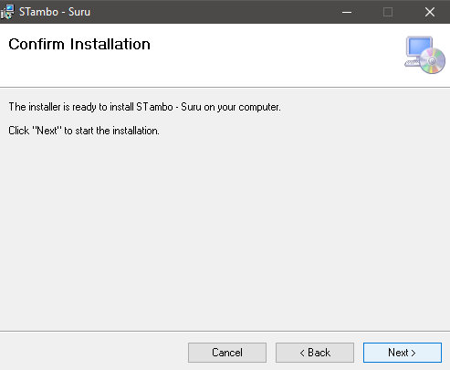

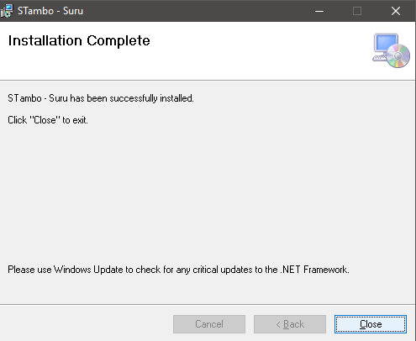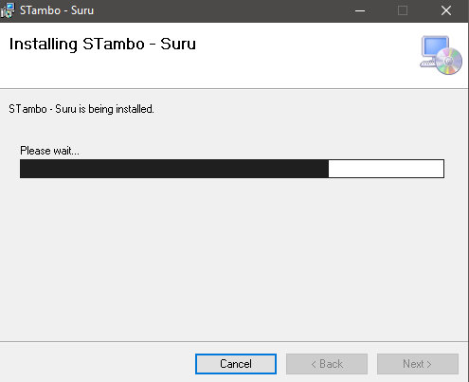Una vez finalizado éste proceso cerramos.

Como podemos observar, se han creado en el escritorio y en el menú de inicio de nuestro sistema operativo, el acceso directo (Ejecutable) de nuestro programa.

